Lighting Web Component.

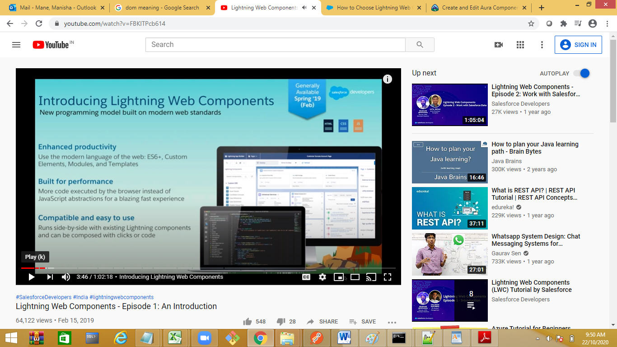



Component

Html

Component

SPA ---

Prerequist- html5,javascript object ,properties, methods,CSS

Class in JS:

Class Employee

{

constructor()

{

}

Method1(){…}

}

<html>

<body>

<h1>welcome <h1>

<script language="javascript">

class emp

{

constructor(name)

{

console.log("object is initilized");

this.name=name;

}

sayHi()

{

alert (this.name);

}

}

let e1=new emp("Manisha");

e1.sayHi();

</script>

</body>

</html>----------------------------

Web Component—a component which we can place on a web page

We can create our own custom web component based on the specifications given by w3c as below

Create a component by extending html element, then add it to the web page DOM , import component , fragments .

Explain SPA concept. Manipulate the DOM to add / remove new component on same page.

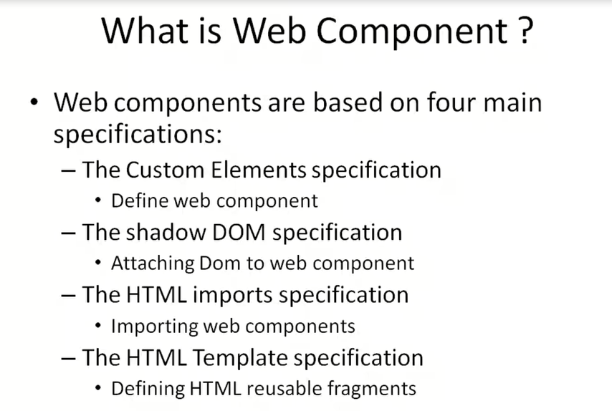

Single Page Application:lWC

Slots and templates:

Template:reusable component

Slot:place holder to add the component.

Ex –onclick want to show a new component.

IN Web Component the root element is template.

In LWS the root element is template, slot is the one where we add the component.

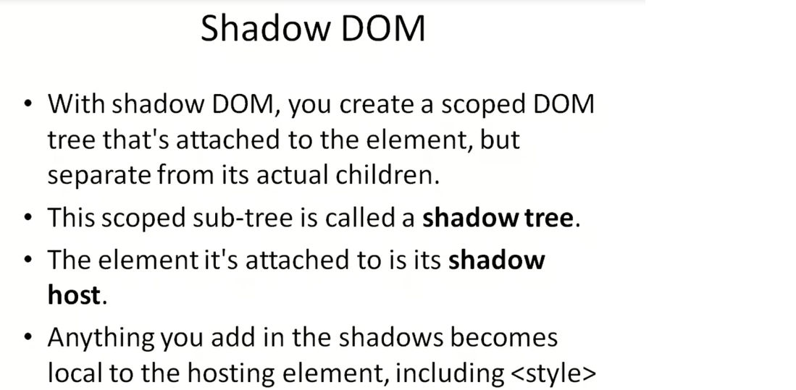

Create a webcomponent.

Add mycomponent in div – actual DOM will get create a shadow

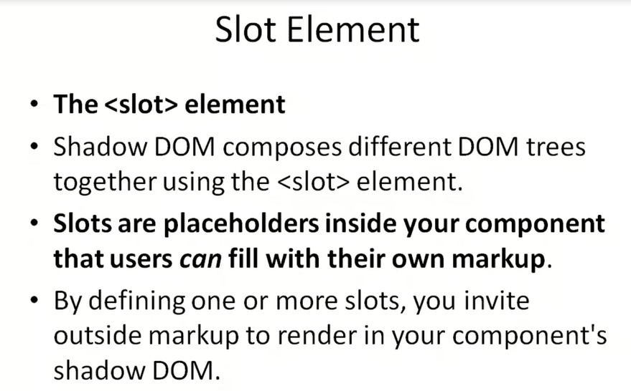

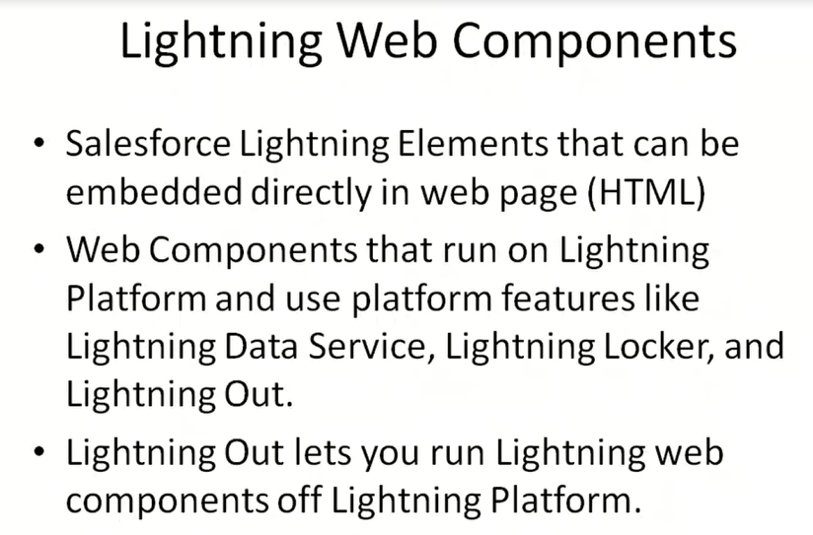

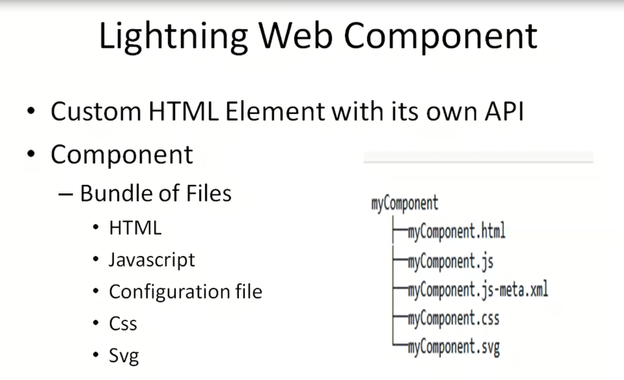

Lightning off will make a component to run in any environment in any web page.

Every web component will have JS associated with it.

Scratch org—to deploy and test the component.

Tool to create a LWC:

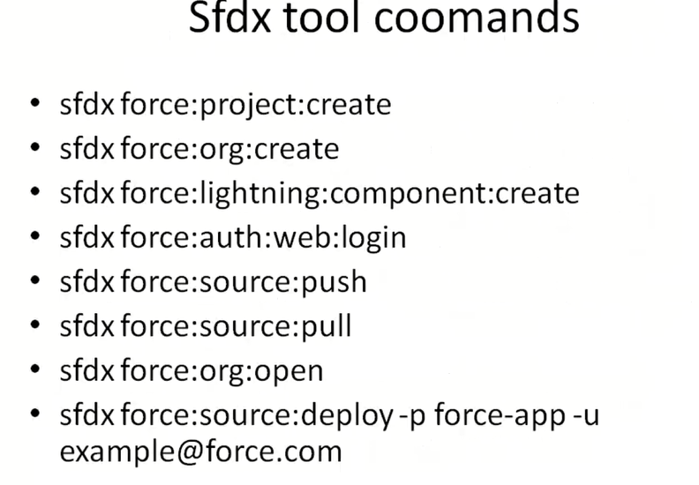

Simple Web Component:

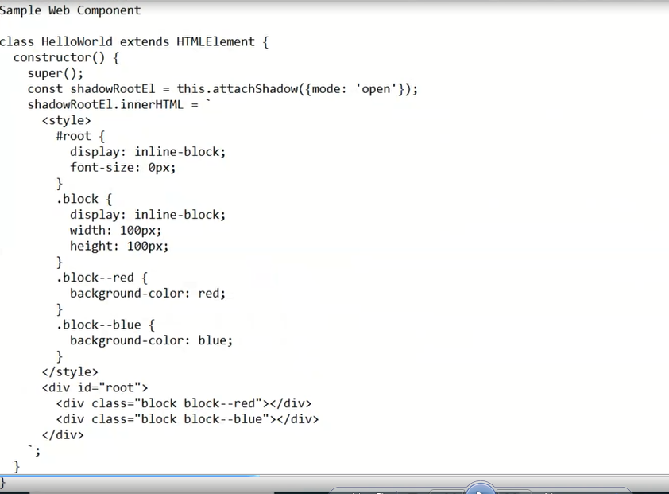

Sfdx – command line interface

<https://developer.salesforce.com/docs/atlas.en-us.sfdx_setup.meta/sfdx_setup/sfdx_setup_install_cli.htm>

for editor: <https://developer.salesforce.com/docs/component-library/documentation/en/lwc/lwc.install_setup_develop>

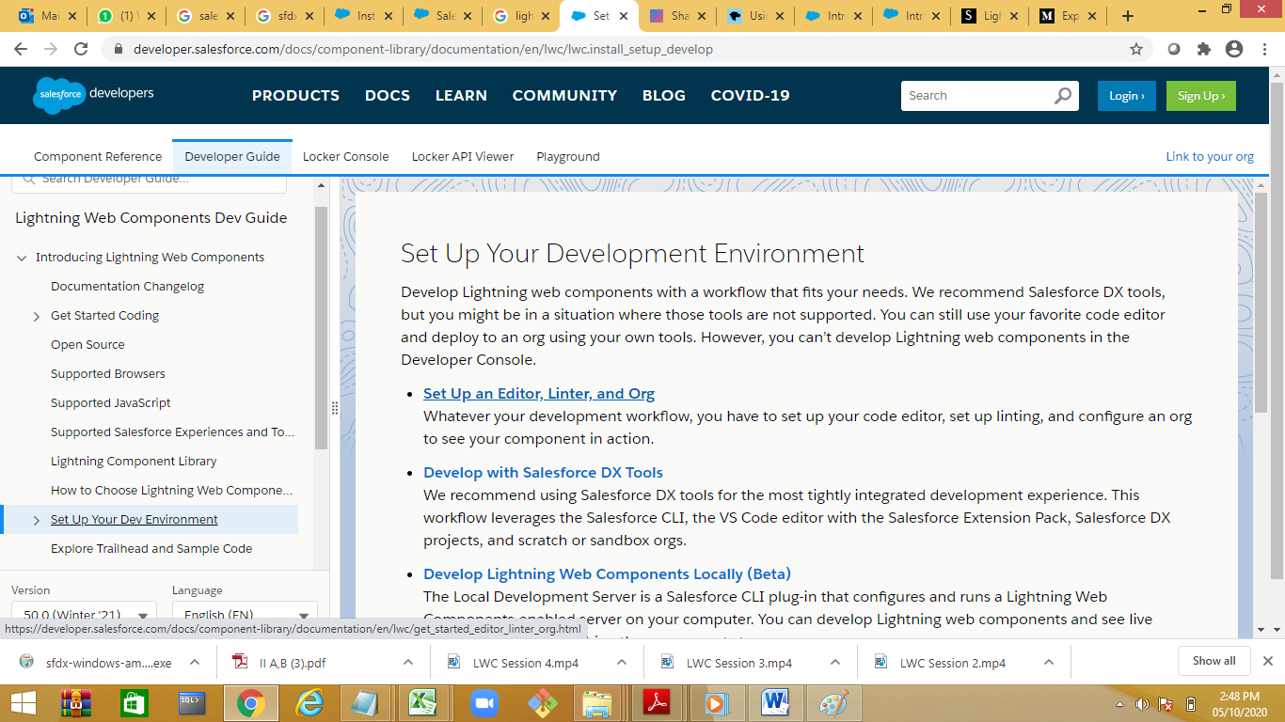

STEPS to CREATE A Lightning Web Componet.

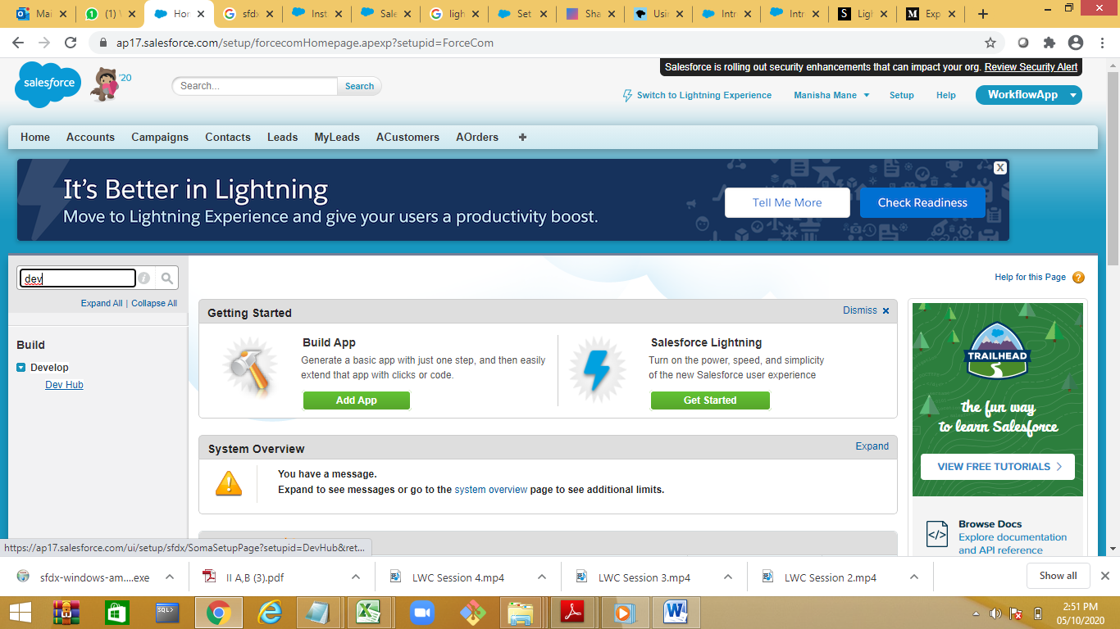

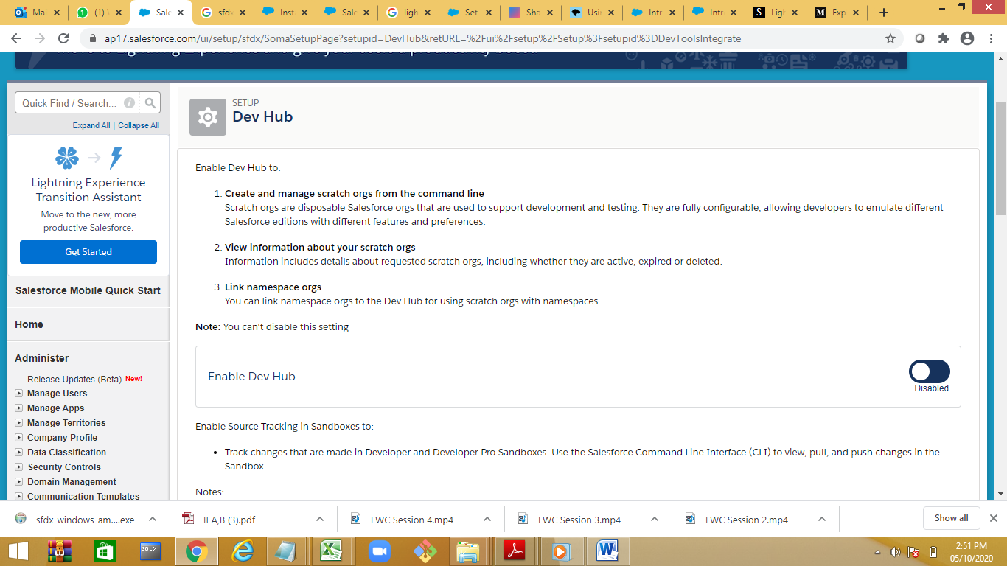

Enable the switch

Step 1: create a project :

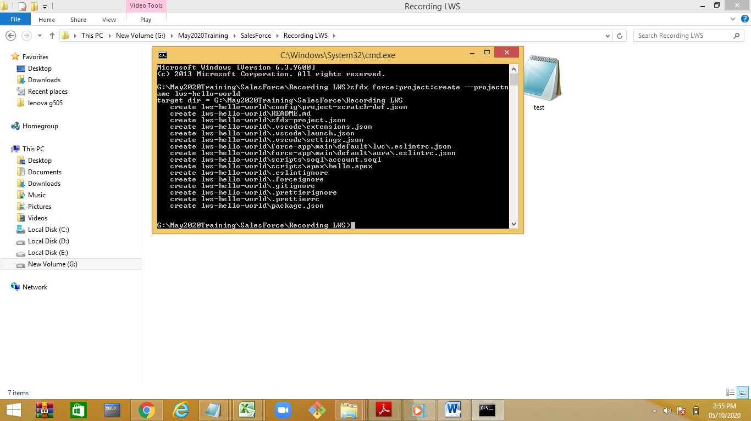

sfdx force:project:create --projectname lws-hello-world

Step 2: create a component:

Sfdx force:lightning:component:create --type lwc -n helloworld -d force-app/main/default/lwc

Type of project can be can be lwc or aura

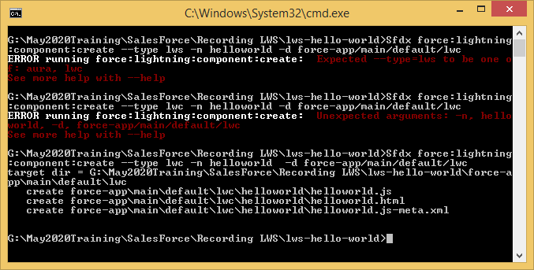

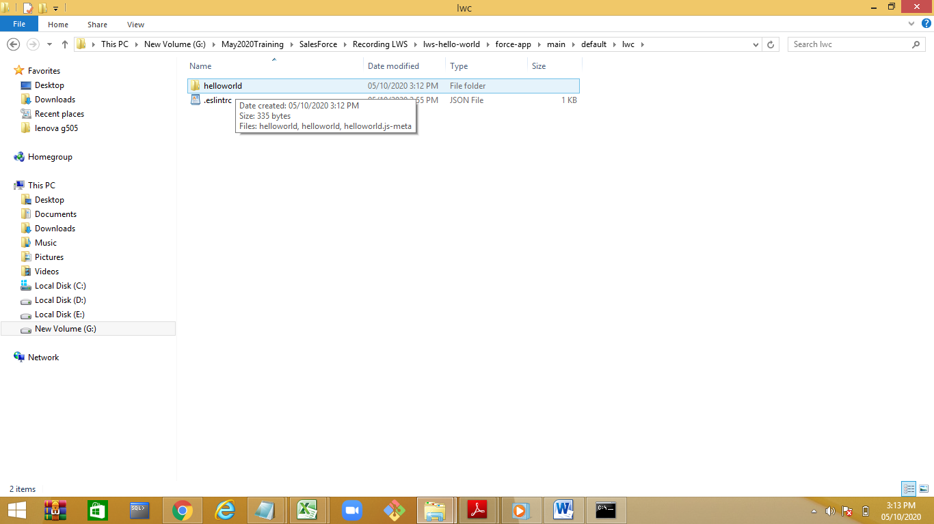

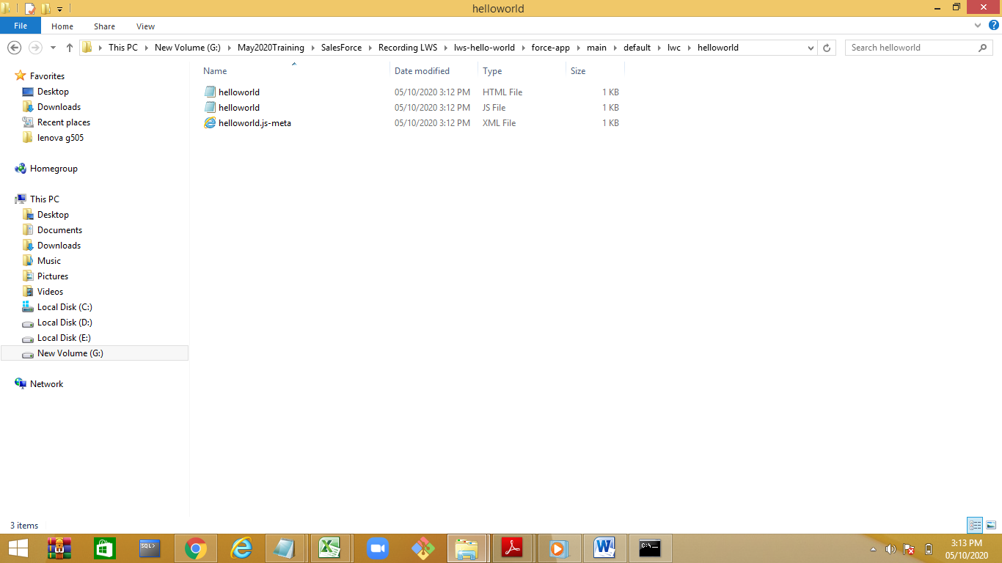

Xml file will specify the scope

isExposed—true/false

targets—where the componenet is available

.xml

<?xml version="1.0" encoding="UTF-8"?>

<LightningComponentBundle xmlns="http://soap.sforce.com/2006/04/metadata">

<apiVersion>49.0</apiVersion>

<isExposed>true</isExposed>

<targets>

<target>lightning__AppPage</target>

<target>lightning_RecordPage</target>

<target>lightning__HomePage</target>

</targets>

</LightningComponentBundle>

.html

<template>

<div>

hello, {name } welcome to LWS

</div>

</template>

.js

import { LightningElement,api } from 'lwc';

export default class Helloworld extends LightningElement {

@api name="Manisha";

}

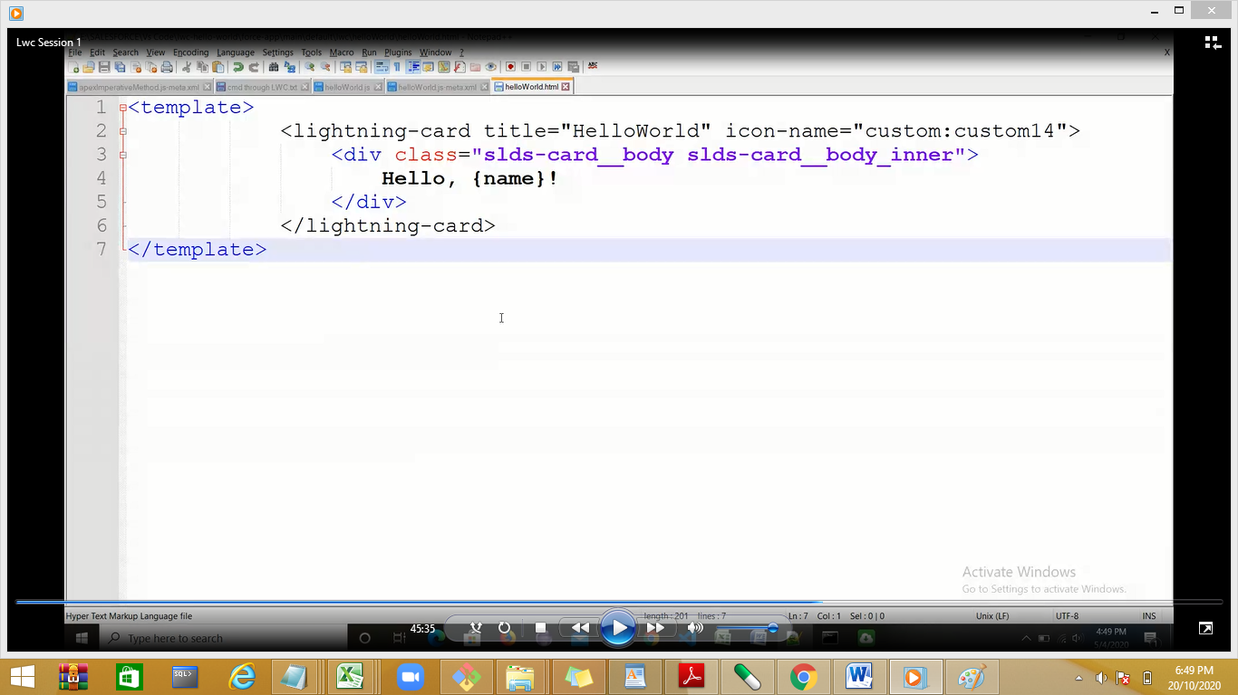

Step 3: authorize the org:

sfdx force:auth:web:login -d –a

will open the login page login to org: [manisha@demo.com](mailto:manisha@demo.com)

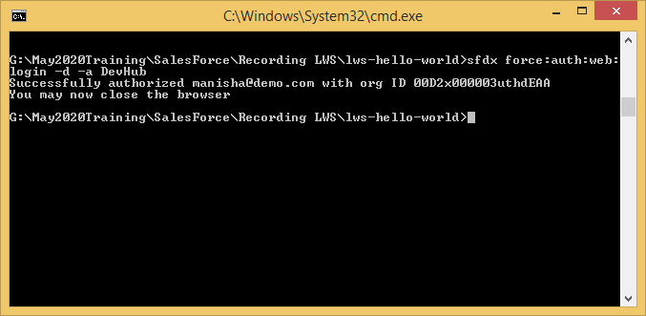

Create a scratch org:

Sfdx force:org:create -s -f config/project-scratch-def.json -a “lwchelloworld”

Sfdx force:auth:web:login

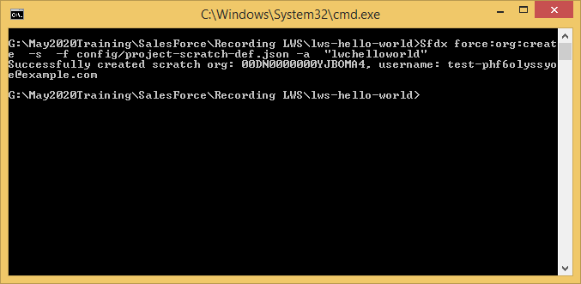

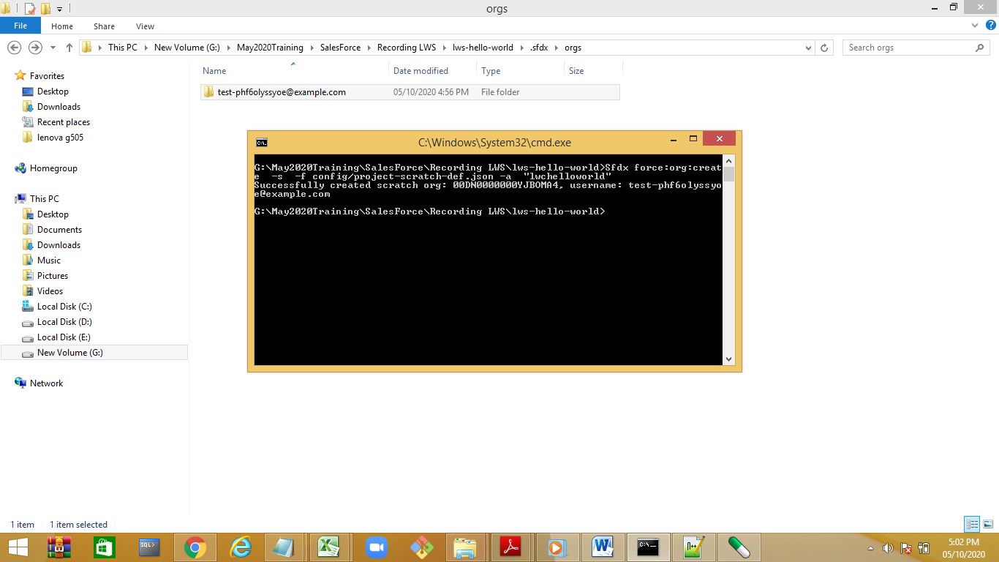

Deploy the component

Sfdx force:source:deploy –p force-app

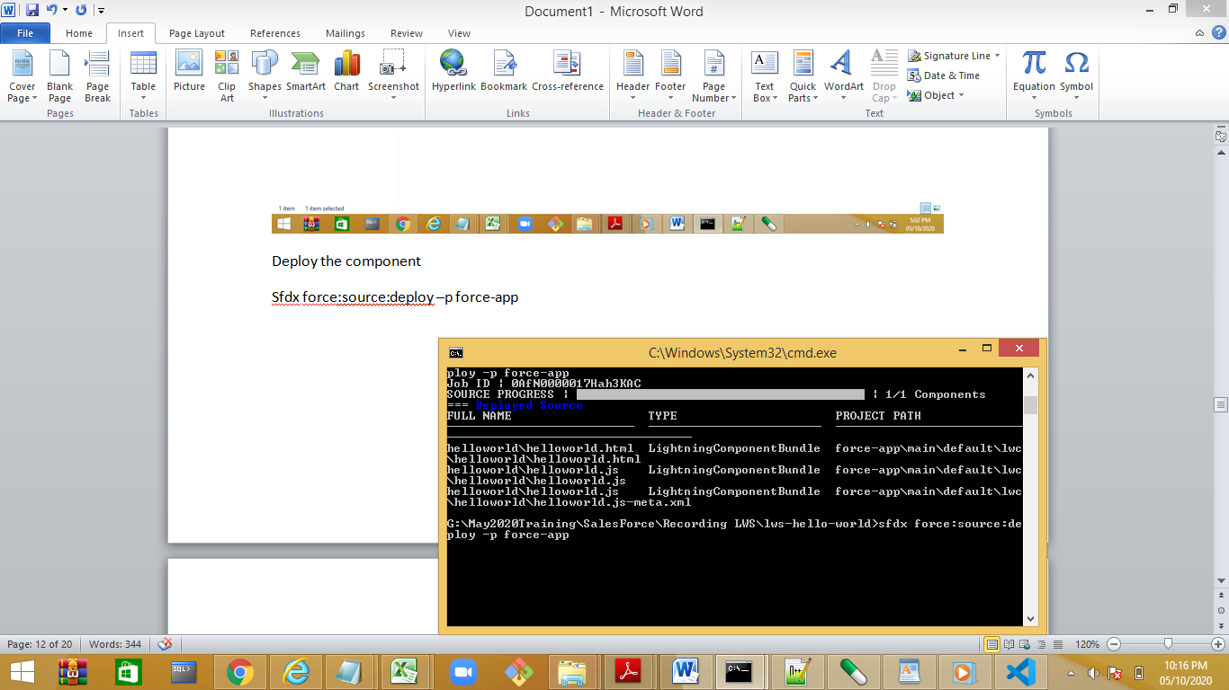

Check the output.

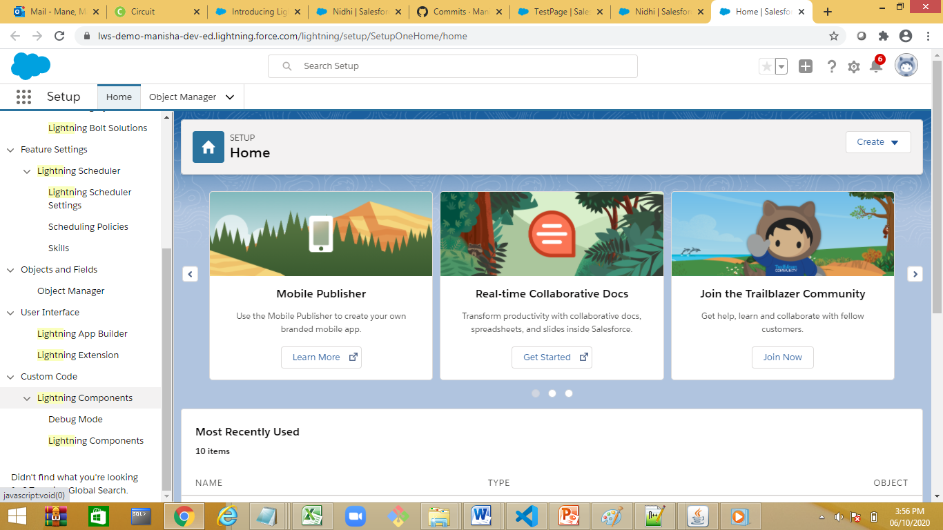

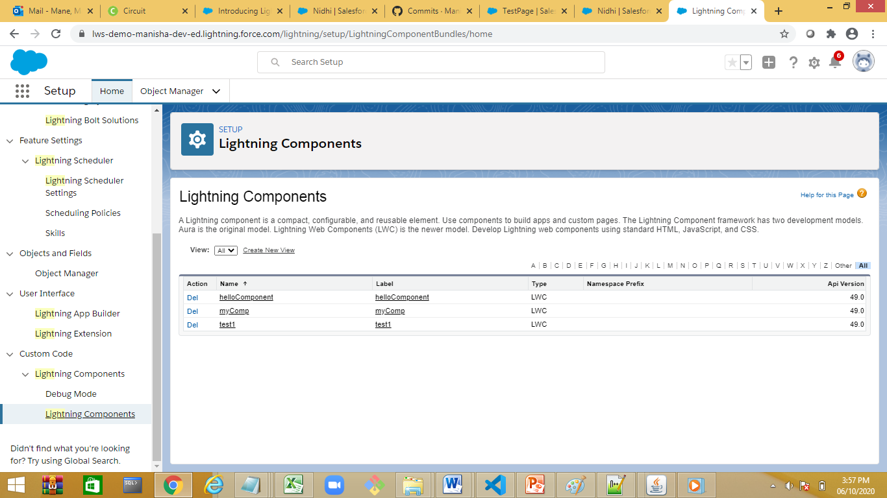

Create a new page

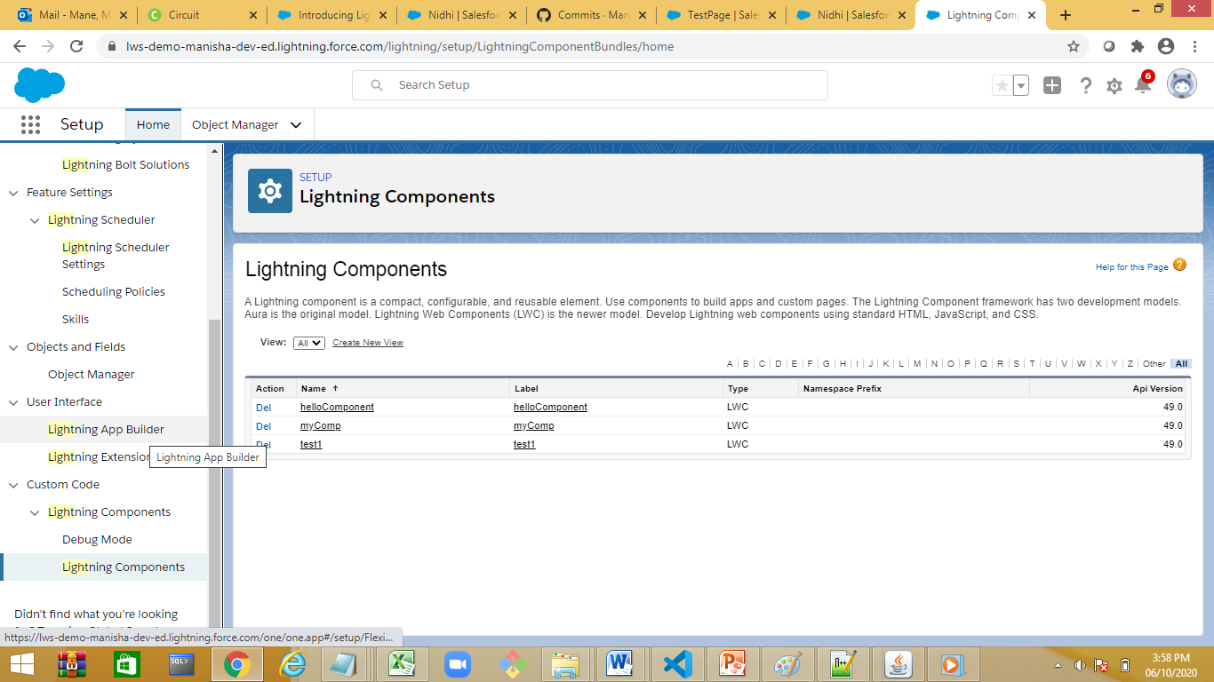

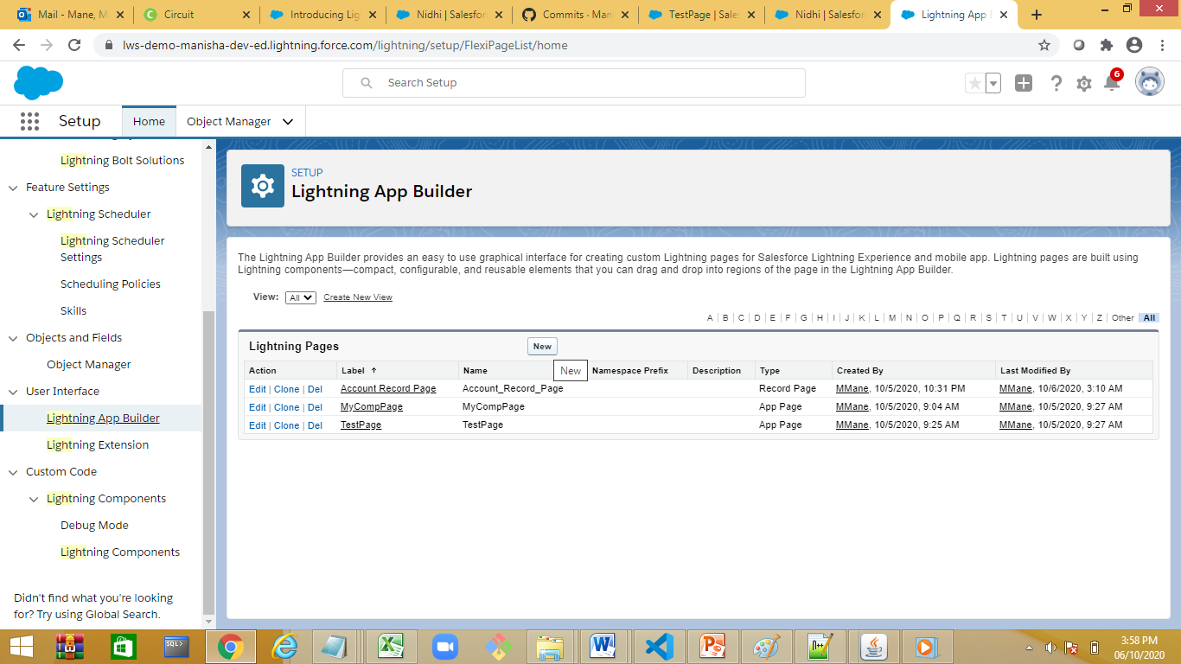

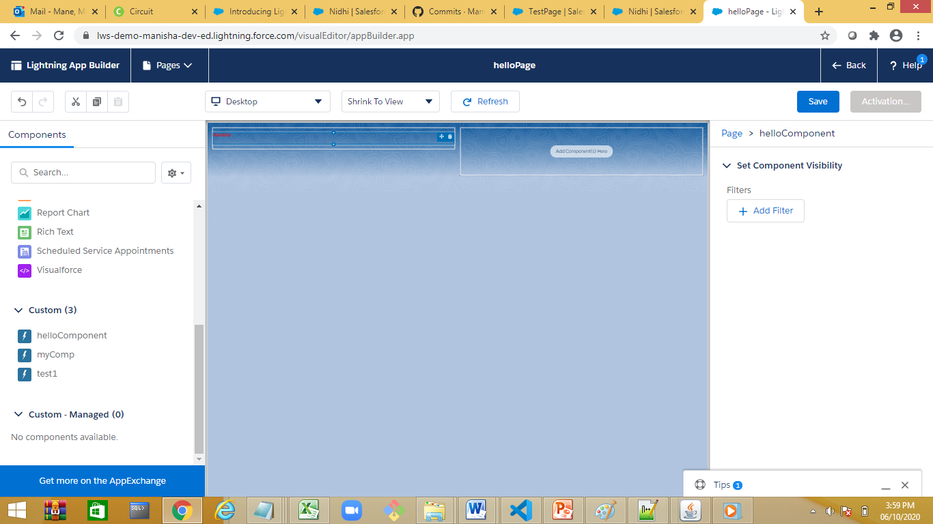

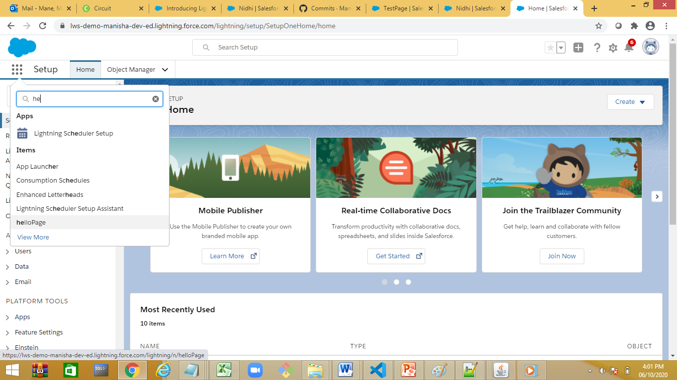

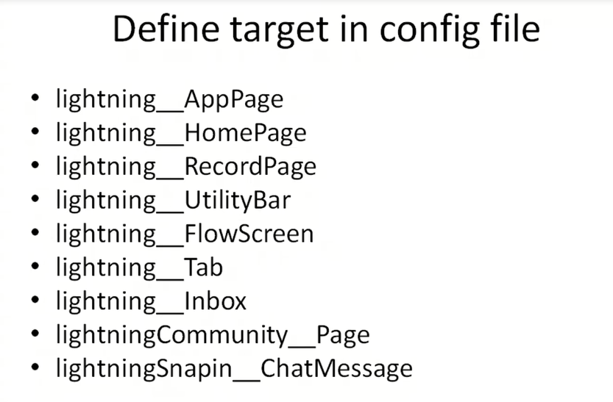

Demo with visual code

Check for salesforce extension

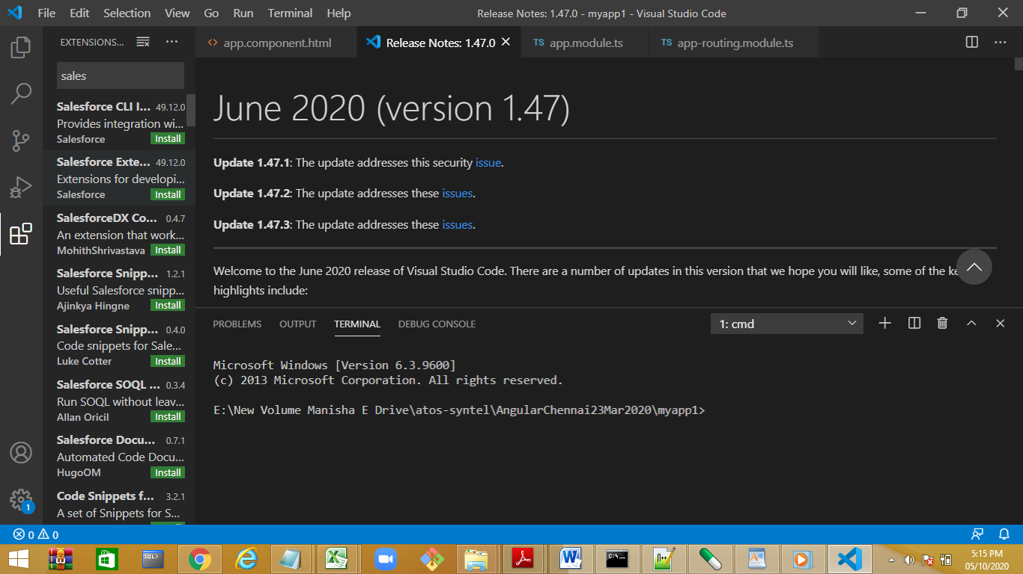

Ctrl+shift+p

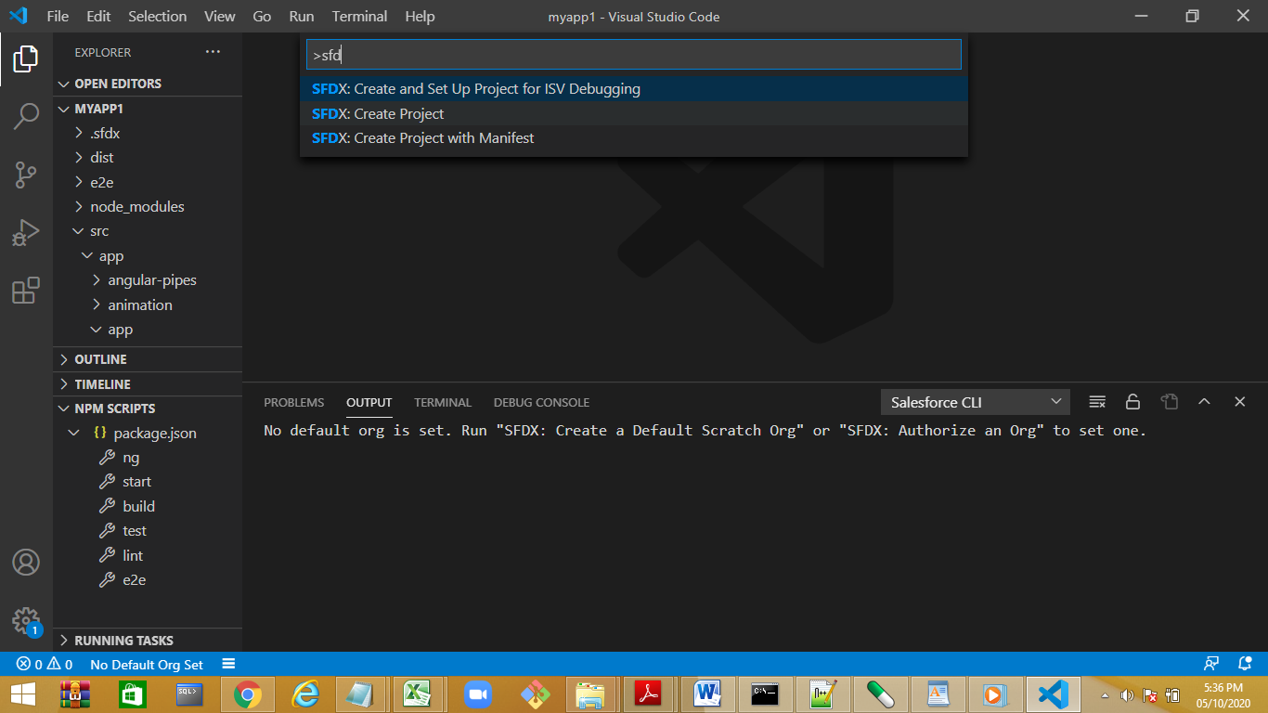

Create a standard project

Authorize the org

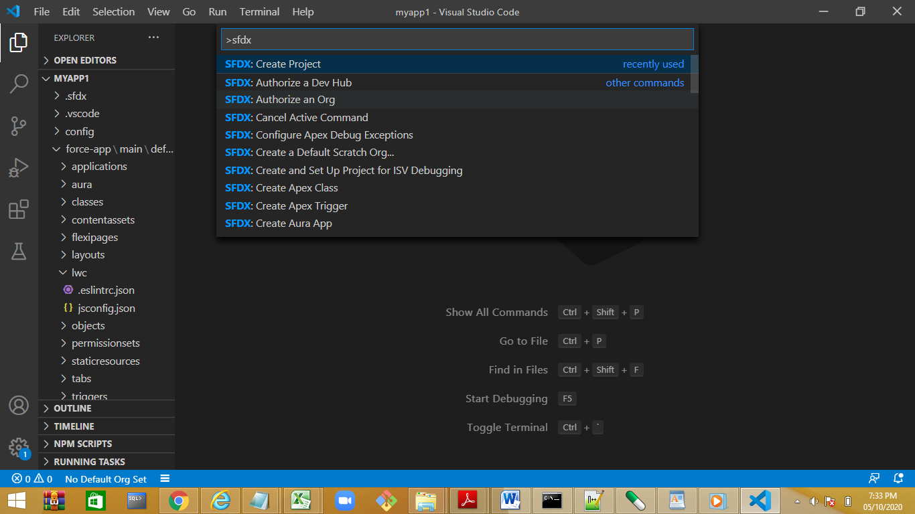

Step 3: create a LWC component.

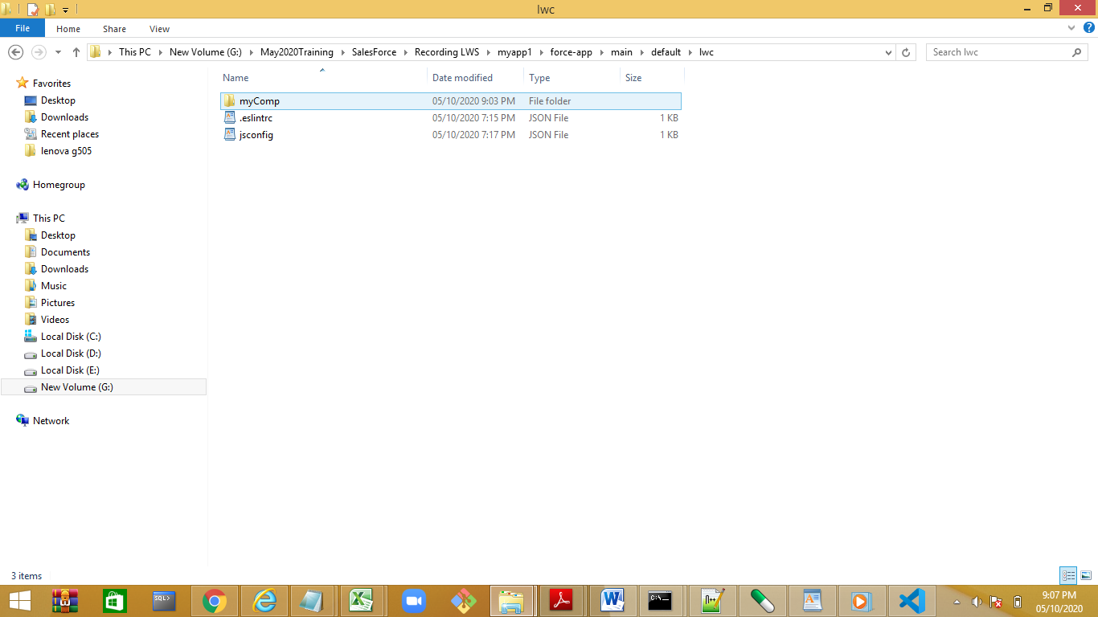

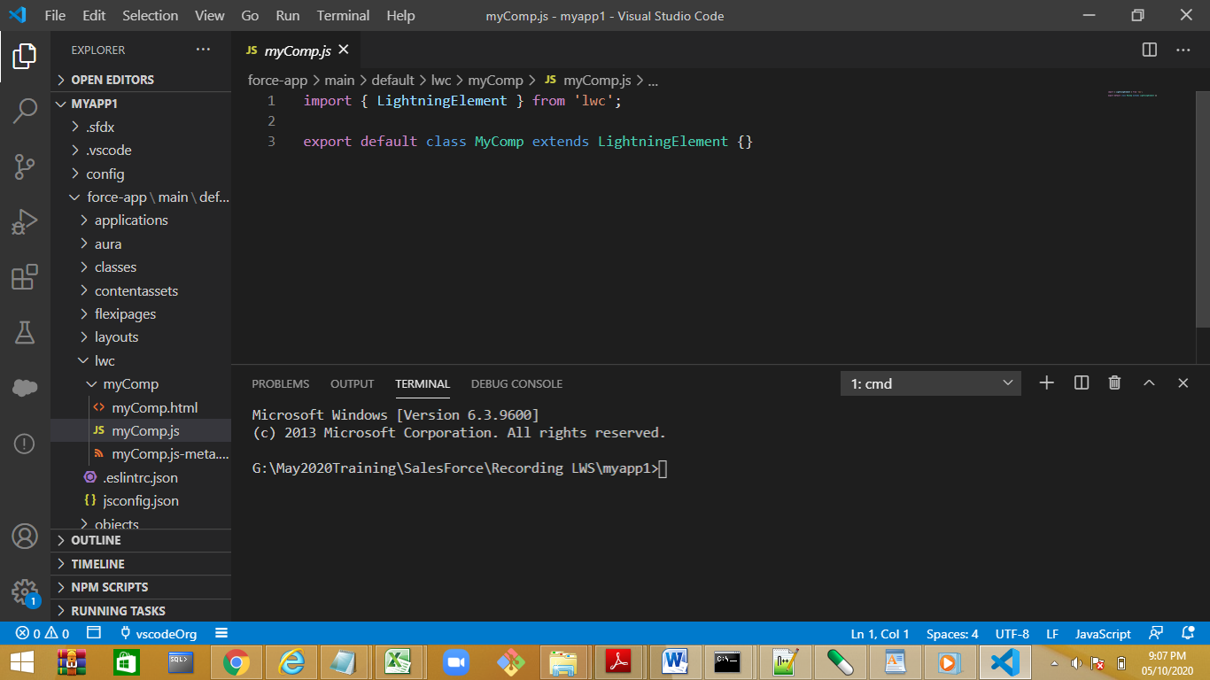

Deploy the component

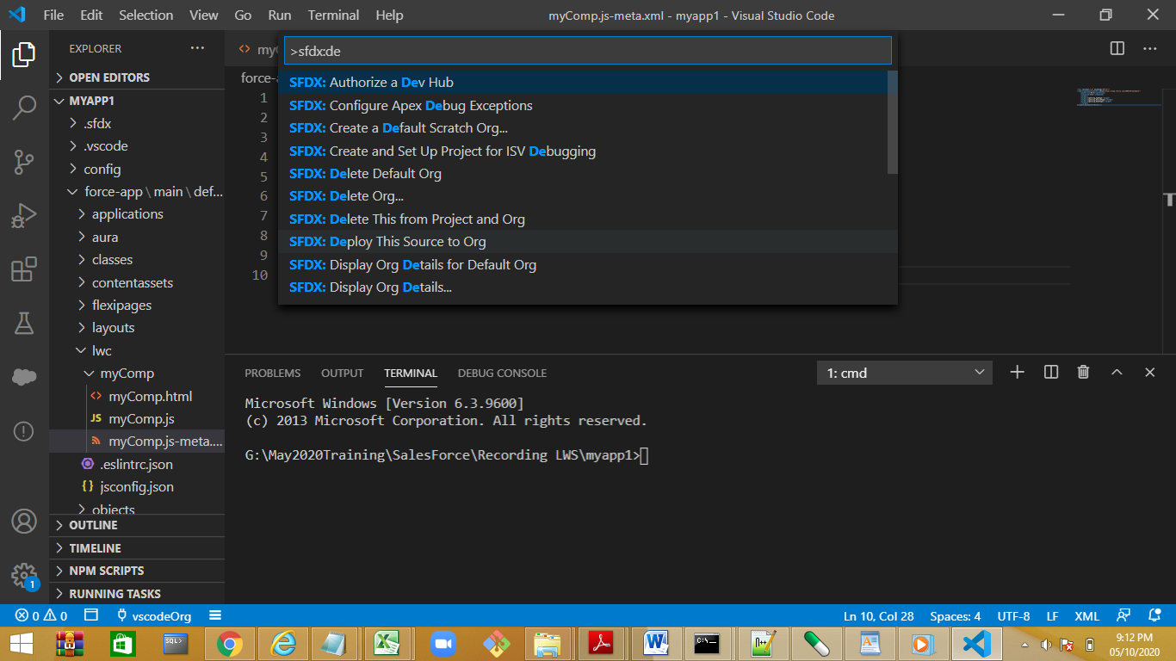

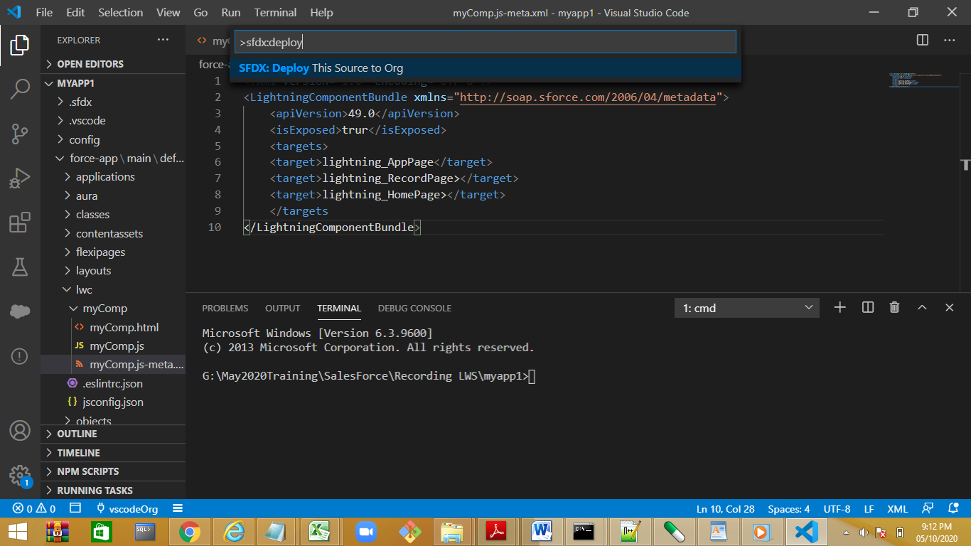

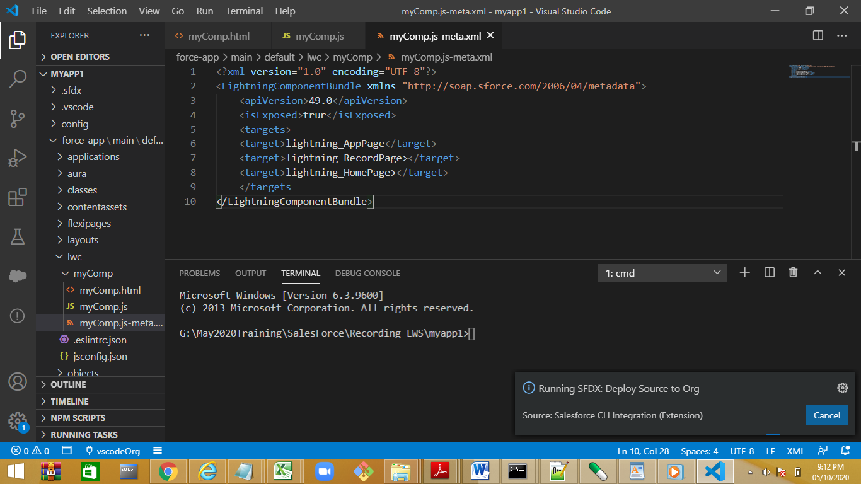

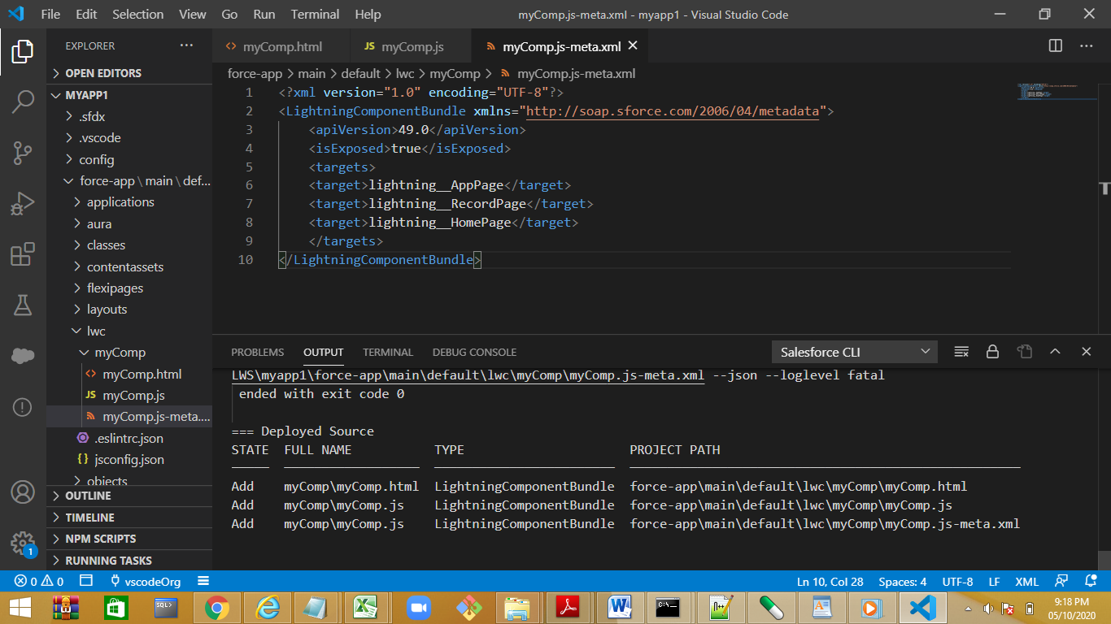

Switch to lightning experience

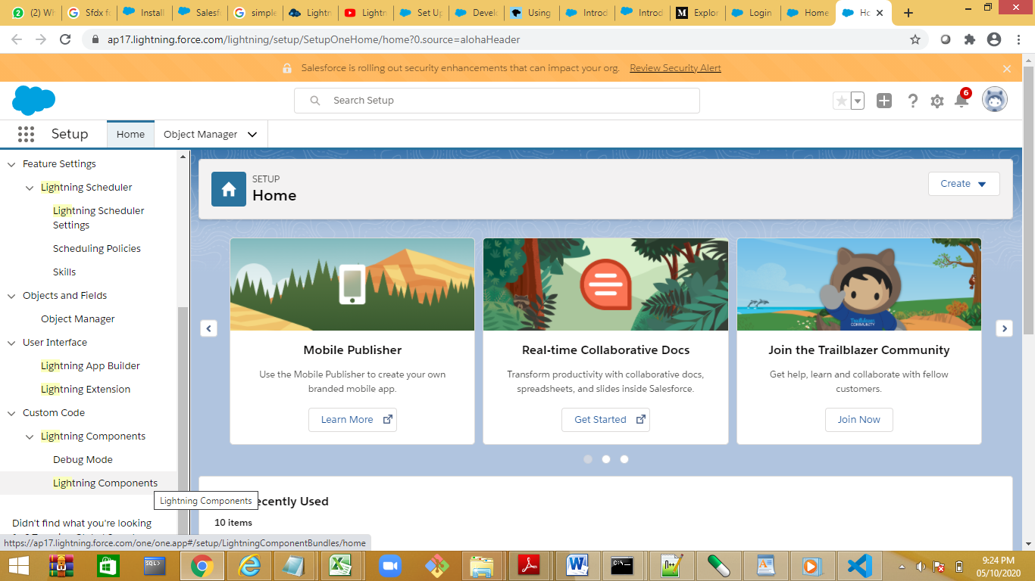

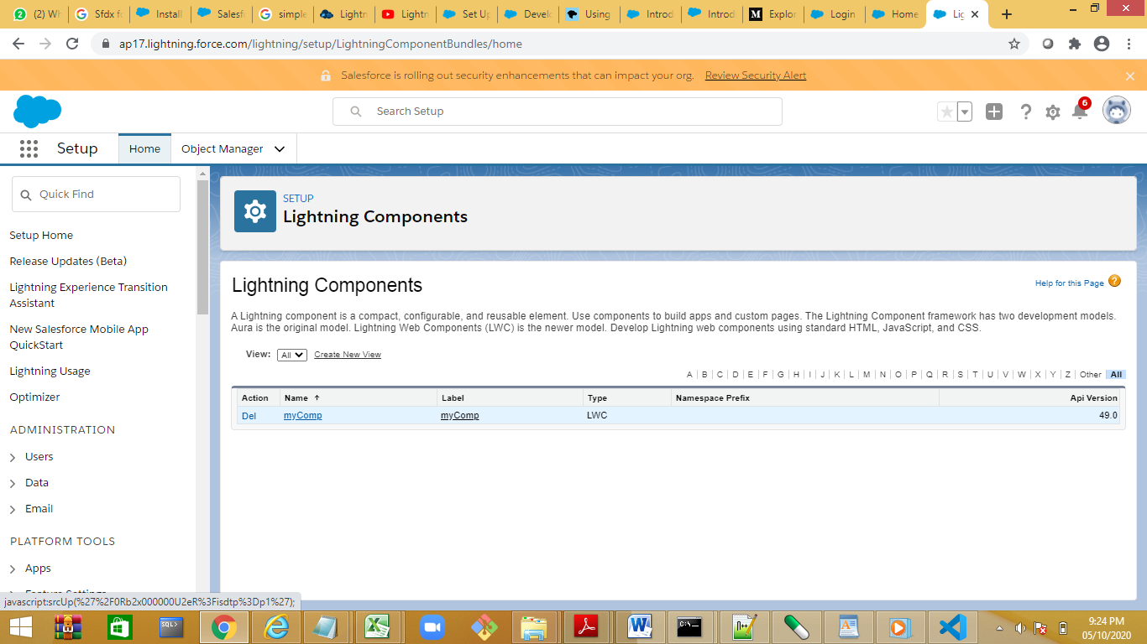

Create a new page with lightning app builder

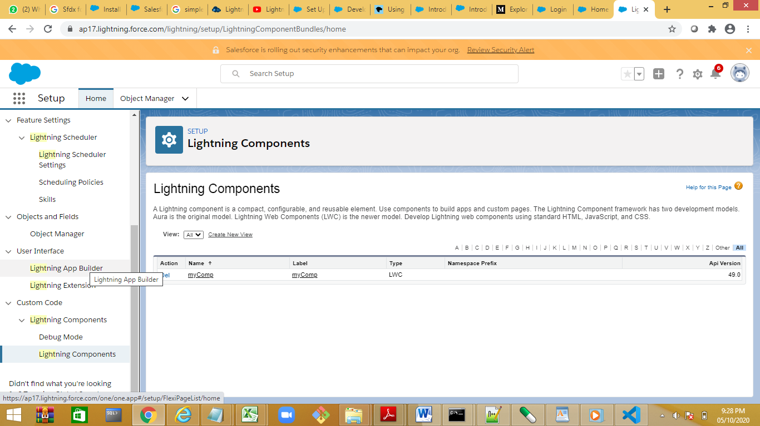

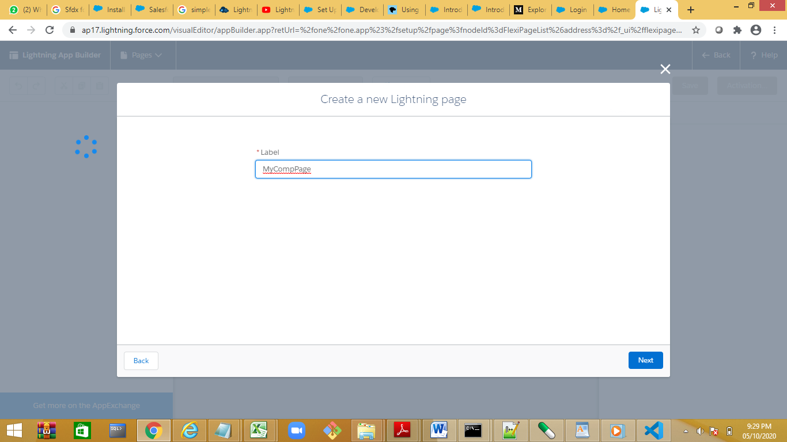

If the component is not visible deploy the domain

lws-demo-manisha-dev-ed

add components

setup🡪lightning bolt dolution

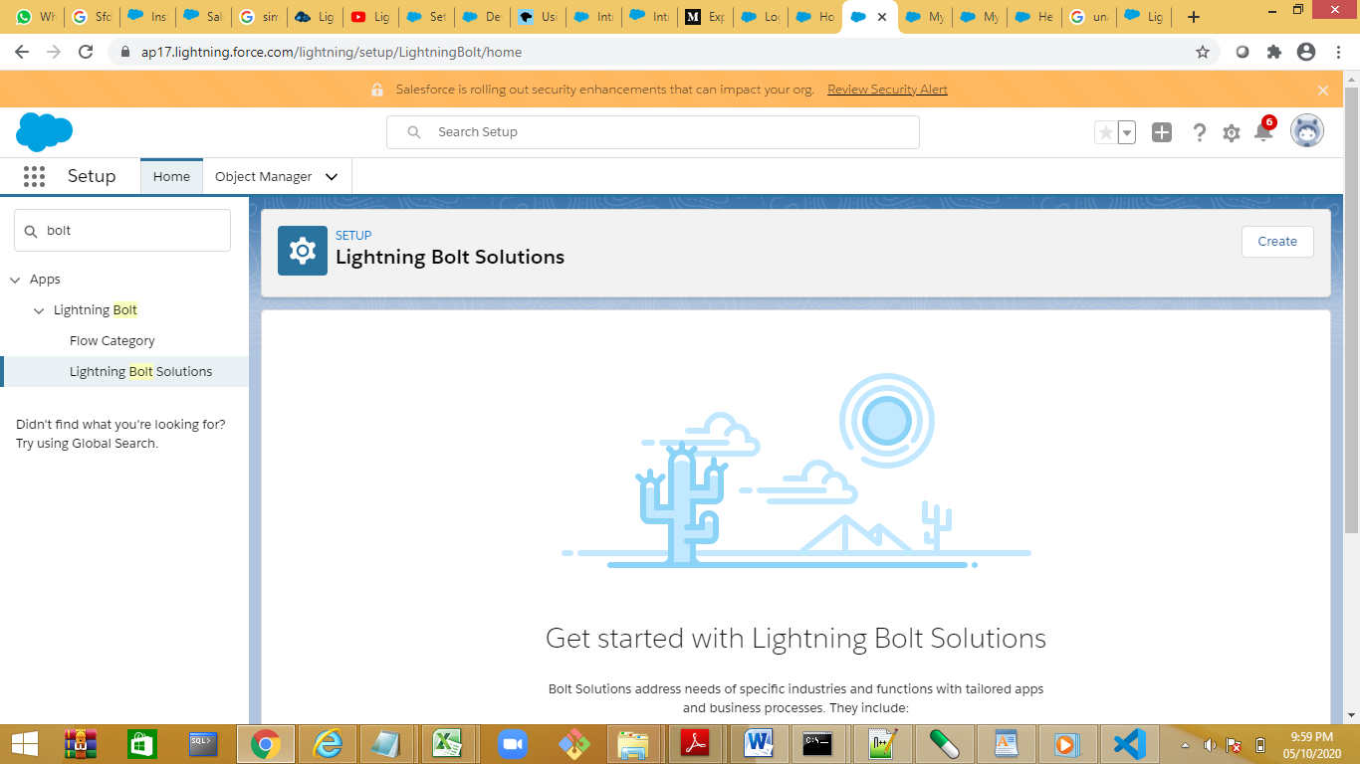

Demo event handling :Bind function to a template

<template>

    <h1><font color='red'><b>{name}</b></font></h1>

    <lightning-input label="Enter Name" value={name} onchange={handleChange} ></lightning-input>

</template>

import {LightningElement,api } from 'lwc';

export default class HelloComponent extends LightningElement {

    @api name="Manisha";

    handleChange(event)

    {

       // alert ("event fired")

        this.name=event.target.value;

    }

}

<template>

    <h1><font color='red'><b>{name}</b></font></h1>

    <lightning-input label="Enter Name" value={name} onchange={handleChange} ></lightning-input>

<p class='slds-m-top_medium'>{uppercaseName}</p>

</template>

import {LightningElement,api } from 'lwc';

export default class HelloComponent extends LightningElement {

    @api name="Manisha";

    handleChange(event)

    {

       // alert ("event fired")

        this.name=event.target.value;

    }

    get uppercaseName()

    {

        return `${this.name}`.toUpperCase();

    }

}

Nested Component.mycomp in hellocomp

<template>

    <h1><font color='red'><b>{name}</b></font></h1>

    <lightning-input label="Enter Name" value={name} onchange={handleChange} ></lightning-input>

<p class='slds-m-top_medium'>{uppercaseName}</p>

<c-my-comp></c-my-comp>

</template>

Fields , properties and attributes

*// todoItem.js*

import { LightningElement, api } from 'lwc';

export default class TodoItem extends LightningElement {

@api itemName = 'New Item';

}

*<!-- todoItem.html -->*

<template>

<div class="view">

<label>{itemName}</label>

</div>

</template>

https://developer.salesforce.com/docs/component-library/documentation/en/lwc/lwc.reactivity_public

regarding

JS FILE:

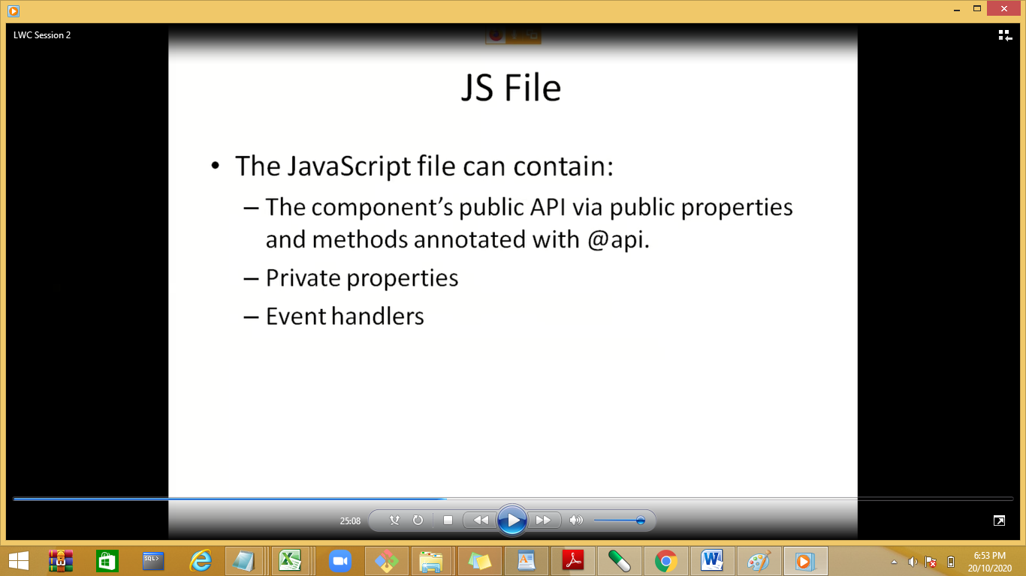

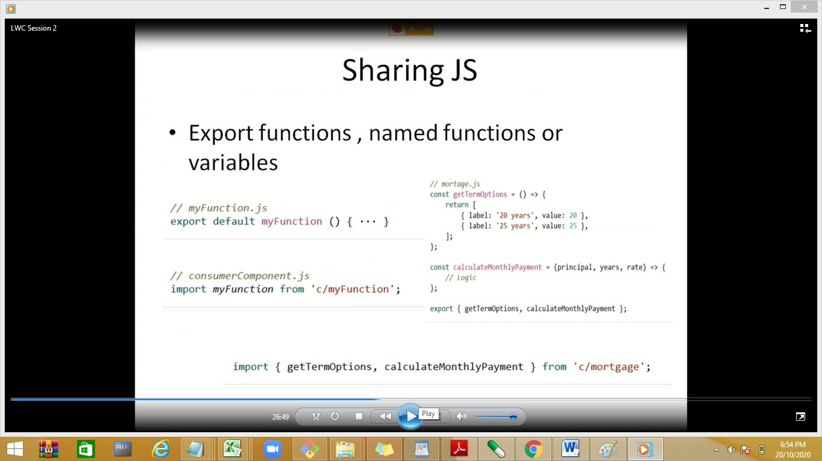

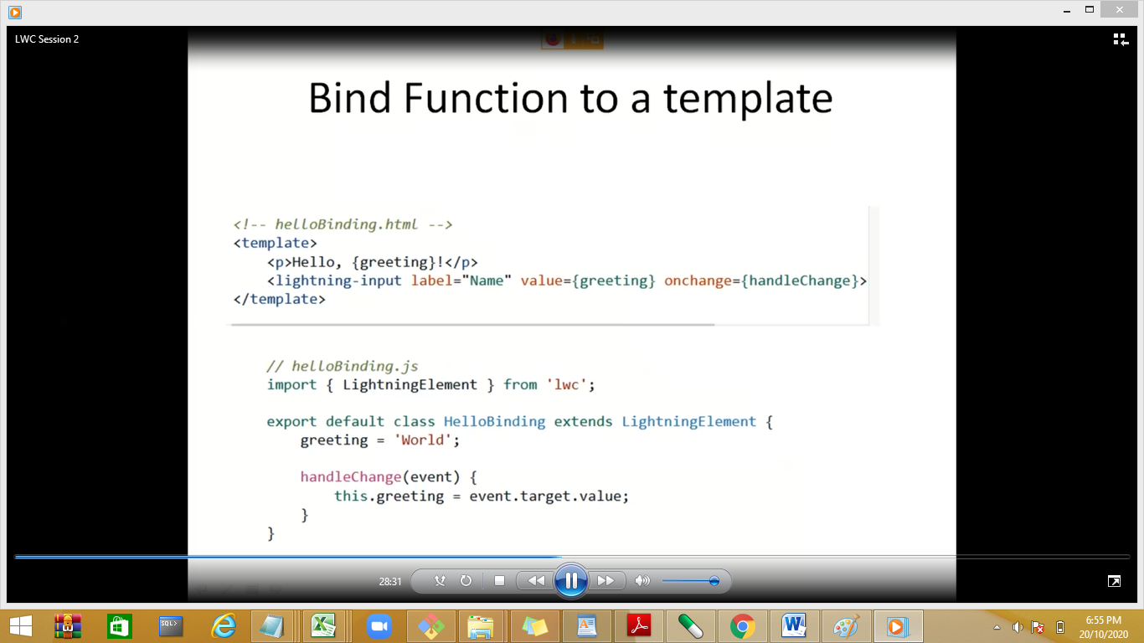

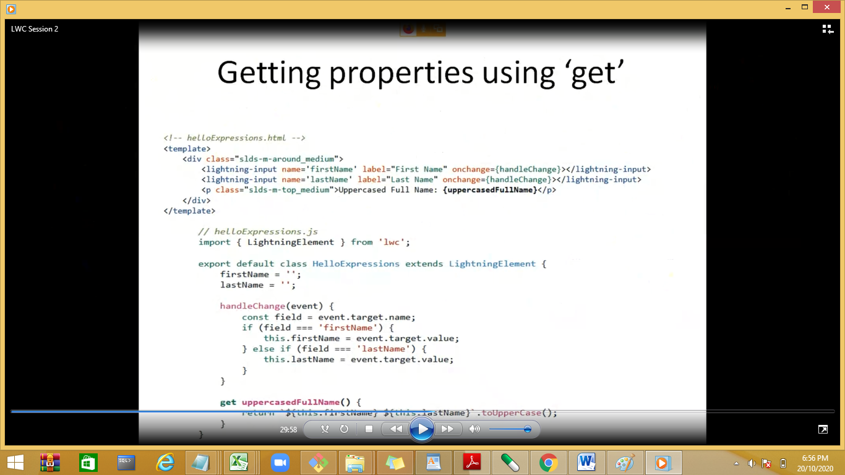

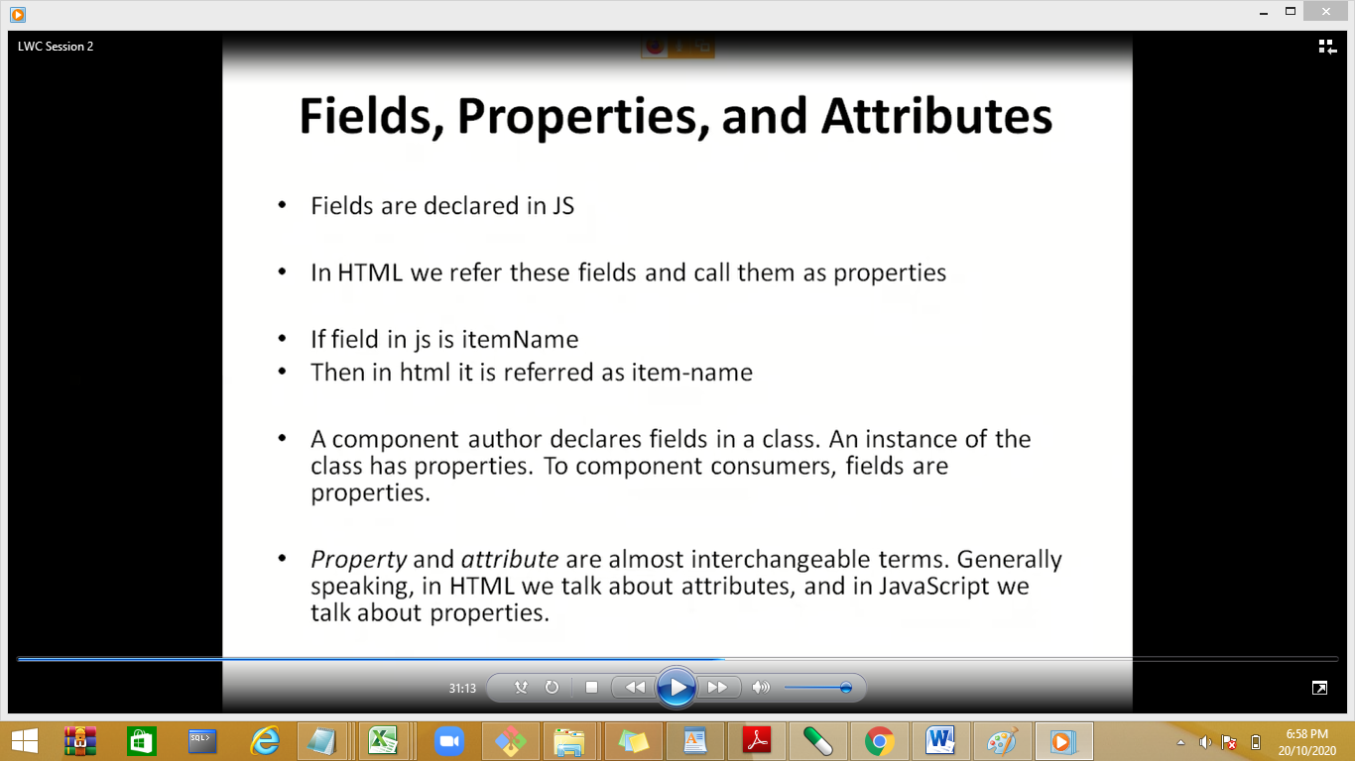

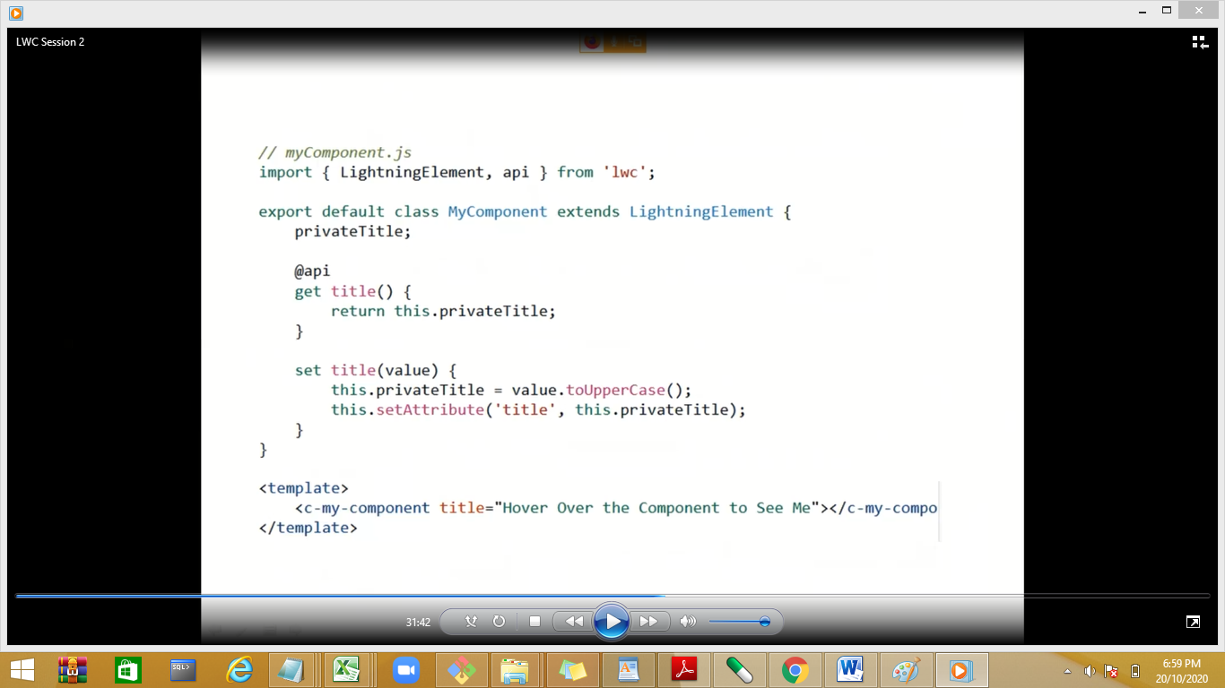

Title is a property / attribute in html

Demos:

<https://www.emizentech.com/blog/properties-in-lightning-web-component.html>

https://www.santanuatonline.com/import-export-javascript-in-lightning-web-component/

Basic Components

lightning-record-form

## lightning-record-view-form

@wires—to get data from salesforce account/.

uiRecordApi—adapter

<https://developer.salesforce.com/docs/component-library/documentation/en/lwc/lwc.reference_get_field_value>

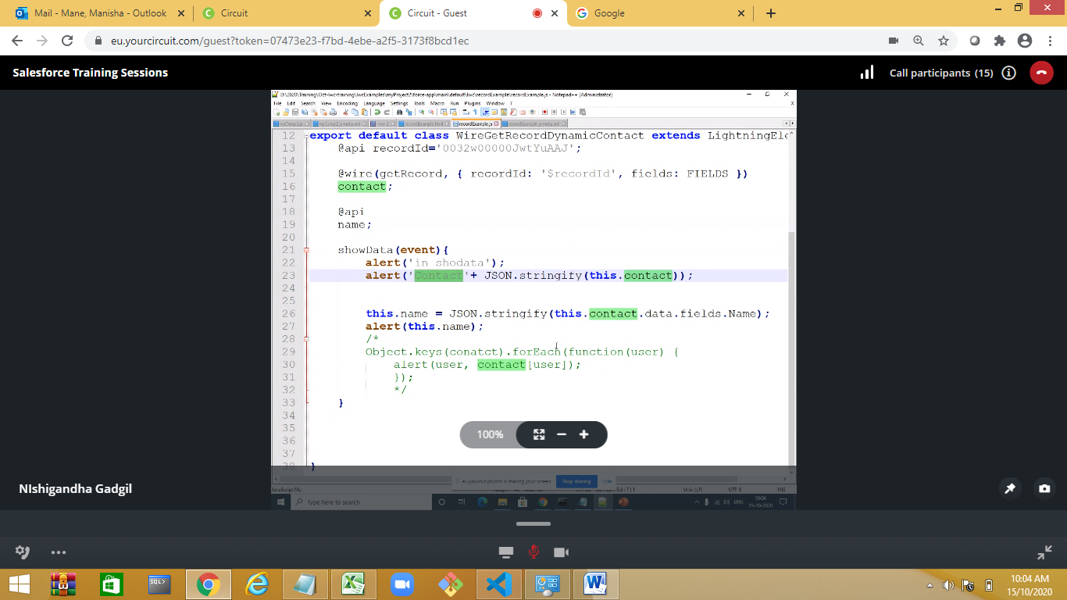

Try foreach to print all properties

Contactwiredemo

WireDemo2

<https://github.com/trailheadapps/lwc-recipes/tree/master/force-app/main/default/lwc> for all lwc demos

https://www.sfdcpoint.com/salesforce/wire-service-lwc-lightning-web-component/

@wire @lightning web component are the mechanism we use to push the data form salesforce object , if we want to run a query then we use Apex Class

Demo on Apex Class:

Method has to public,static

To use Apex method we have to use @AuraEnabled Annotation

Cacheable—true—increase the performance , data will be there in cache

Demo:Apex class in LWS is used for firing query on join ,use rarely

Create an Apex class with Name ContactController

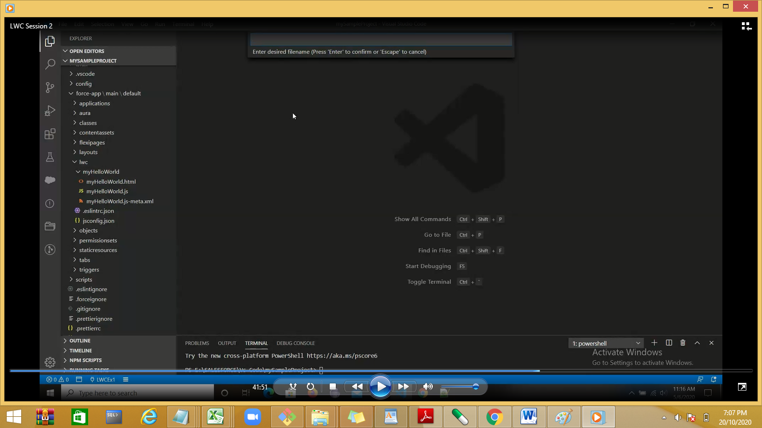

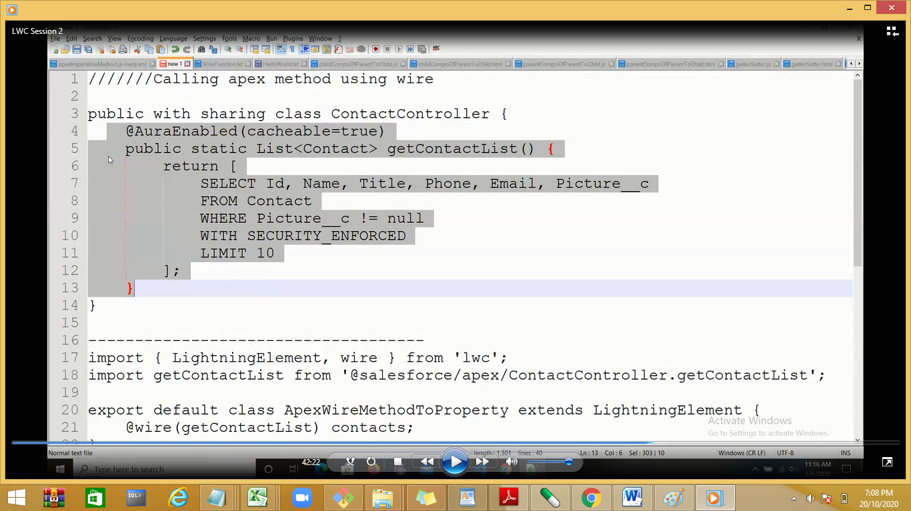

@AuraEnabeld

Step 2:

Create a new LWC

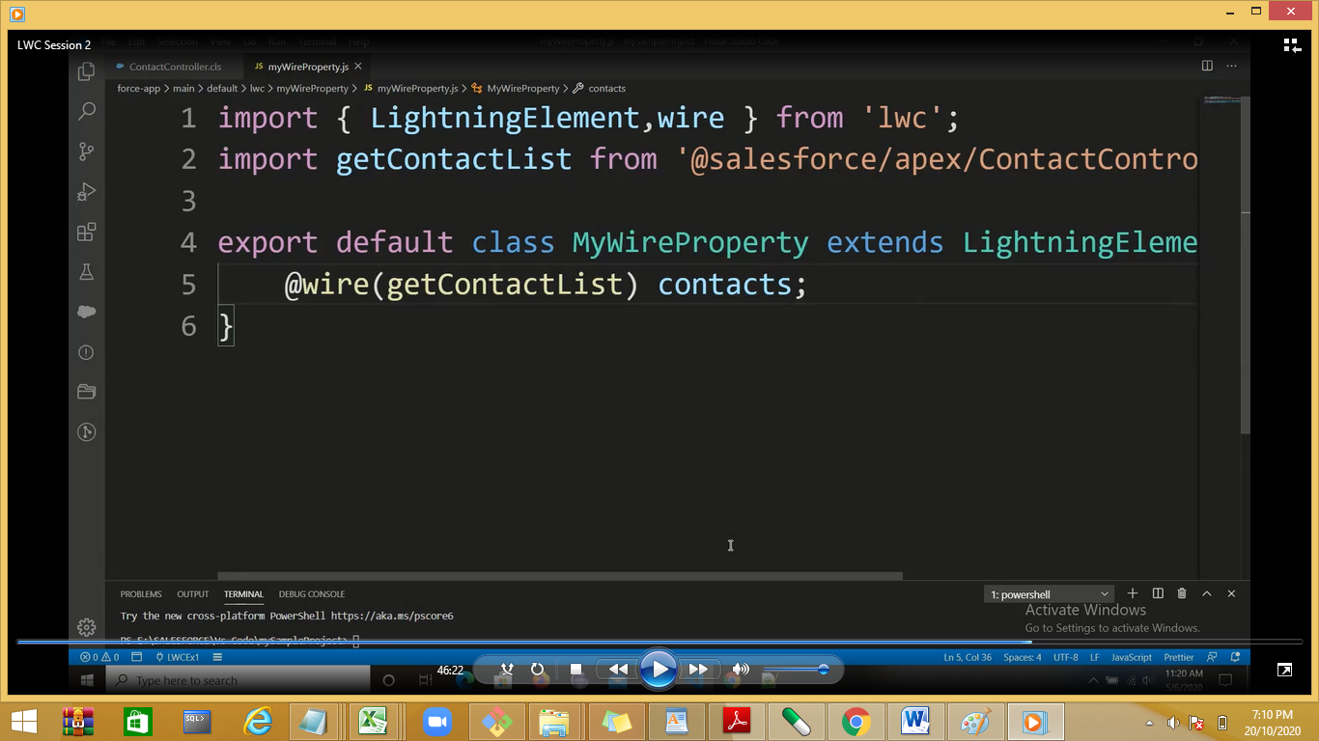

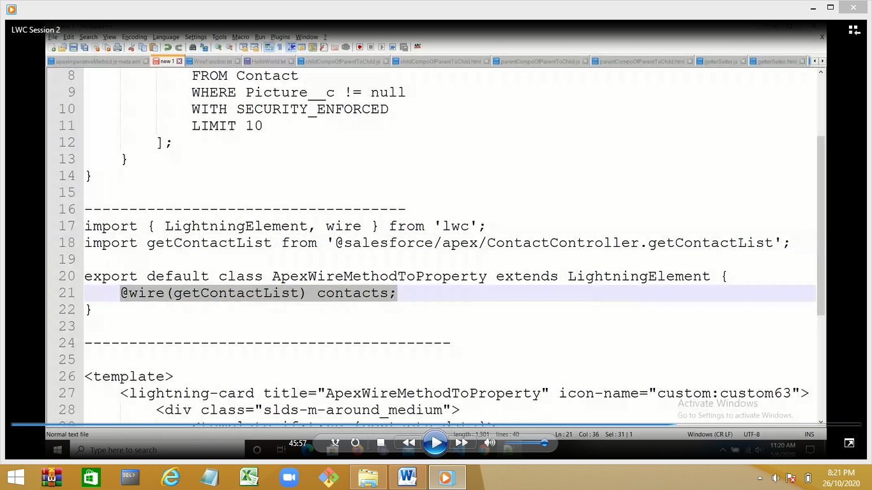

.html code

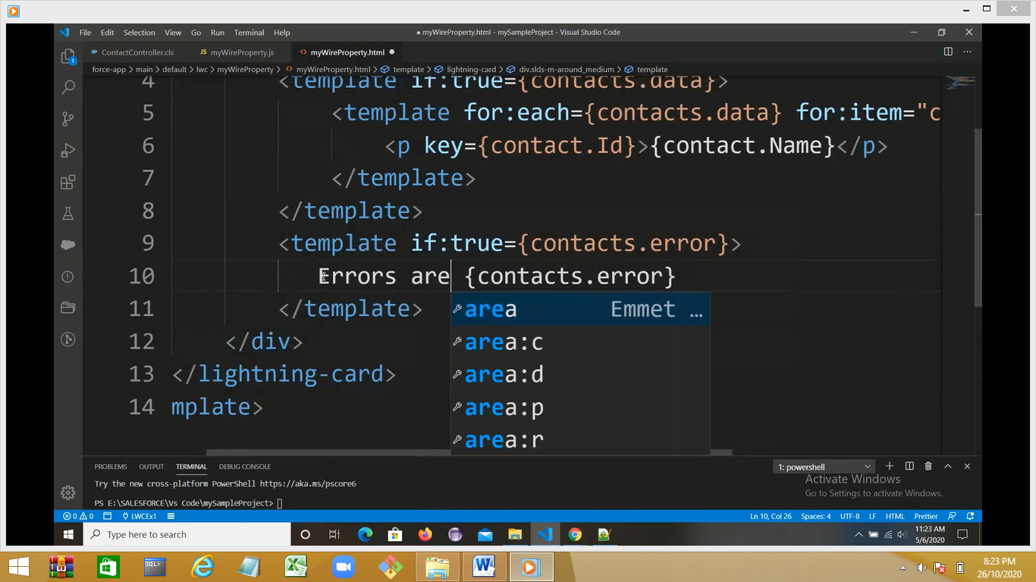

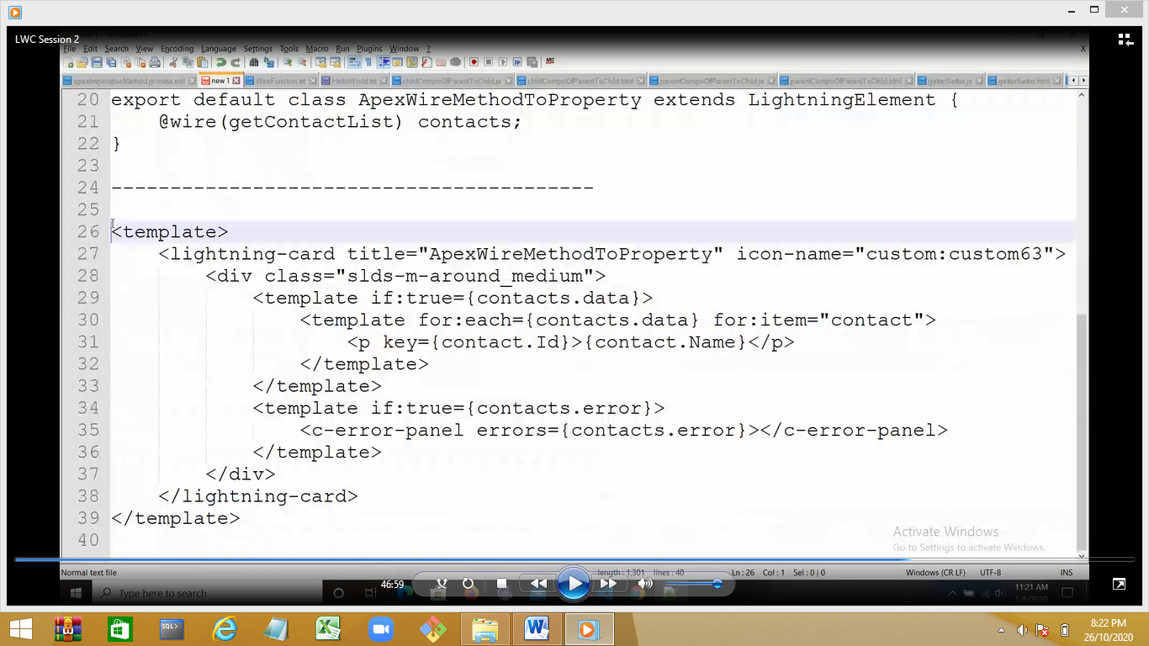

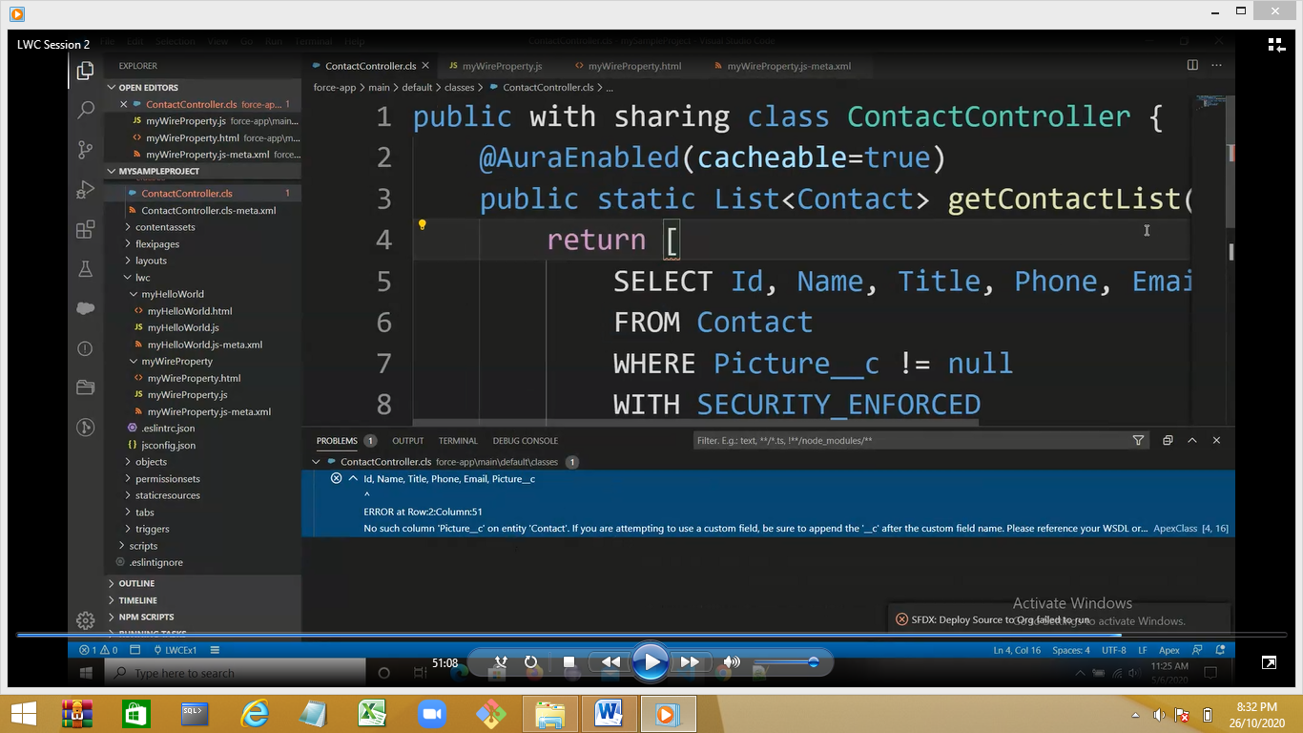

Deploy the ContactController.cls also the meta .xml

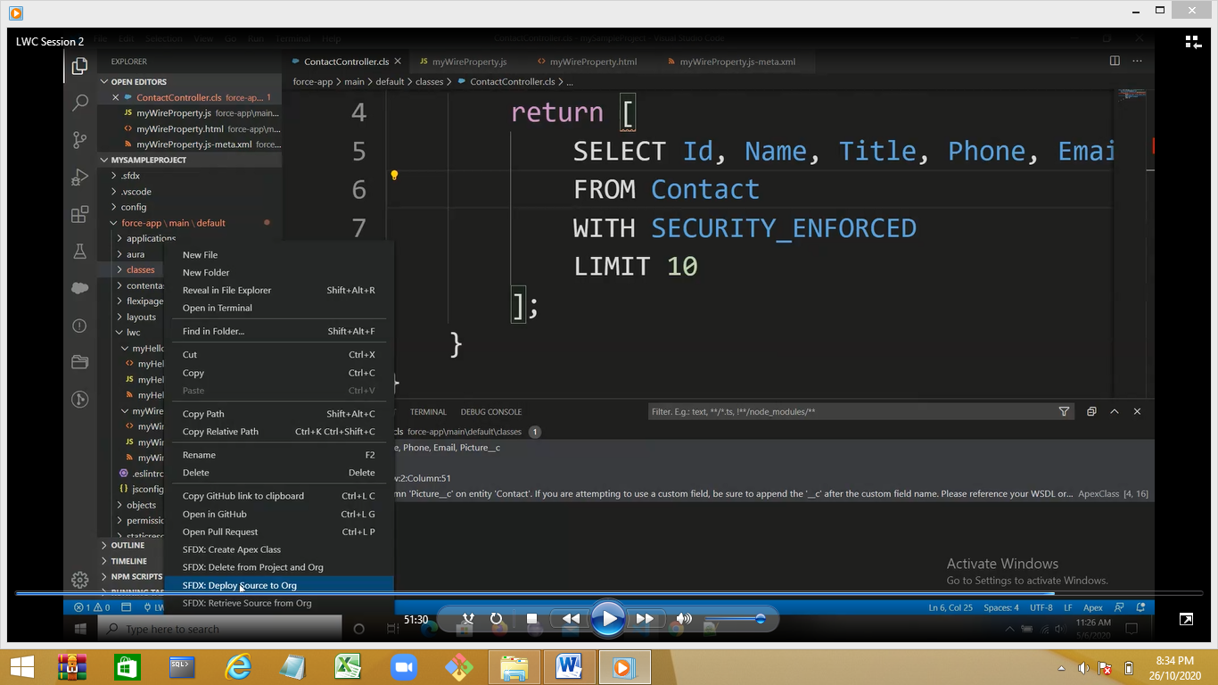

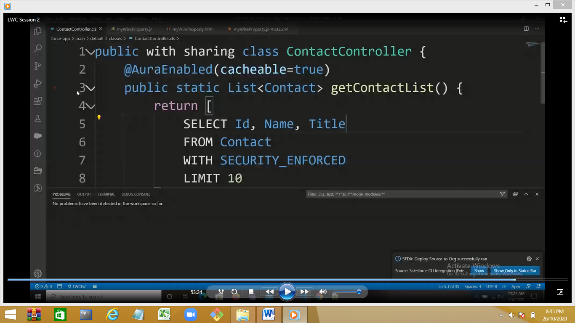

Deploy the LWC

Demo: Apex method with parameters:

https://developer.salesforce.com/docs/component-library/documentation/en/lwc/lwc.apex

<https://www.youtube.com/watch?v=FBKlTPcb614>

salesforce developer

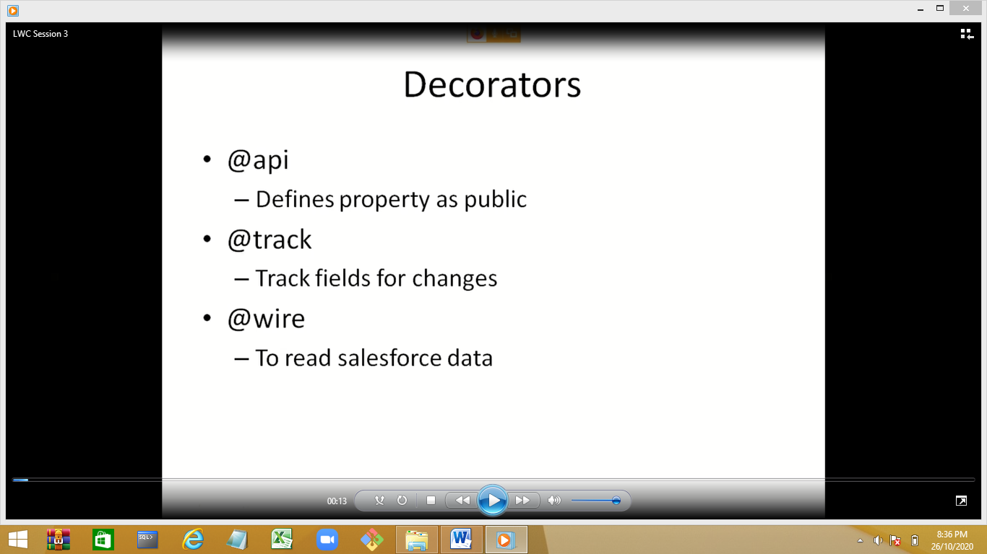

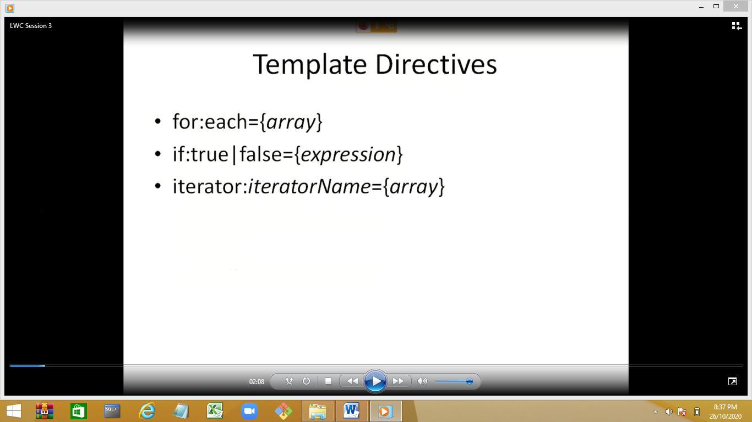

Life Cycle of a LW Component:

Object is created🡪constructor called

When the component is linked to the DOM tree🡪connectedCallback()

Remove component from DOM tree🡪 disconnectedCallback()

If any error🡪errorCallback

Component is rendered to user🡪renderedCallback()

Nested component execustion:

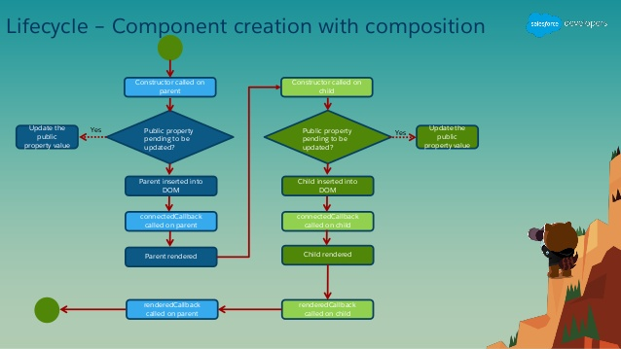

Navigation Service:SPA usec for navigation from 1 page to other.

Create first page with header , footer, left panel, right panel, center panel

Create slots for adding and removing component form middle pane rest will remain same

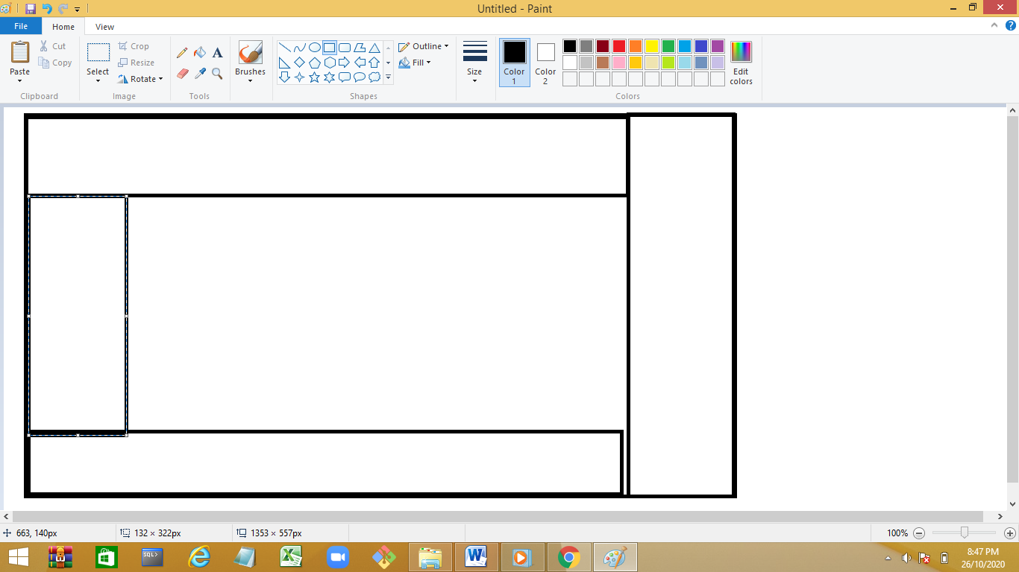

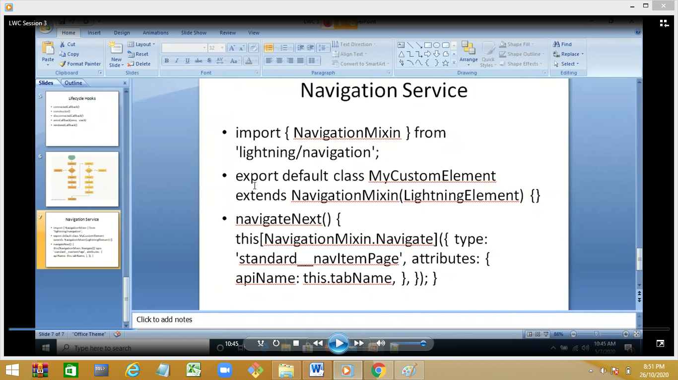

4:

Create a LWC myNamedSlot

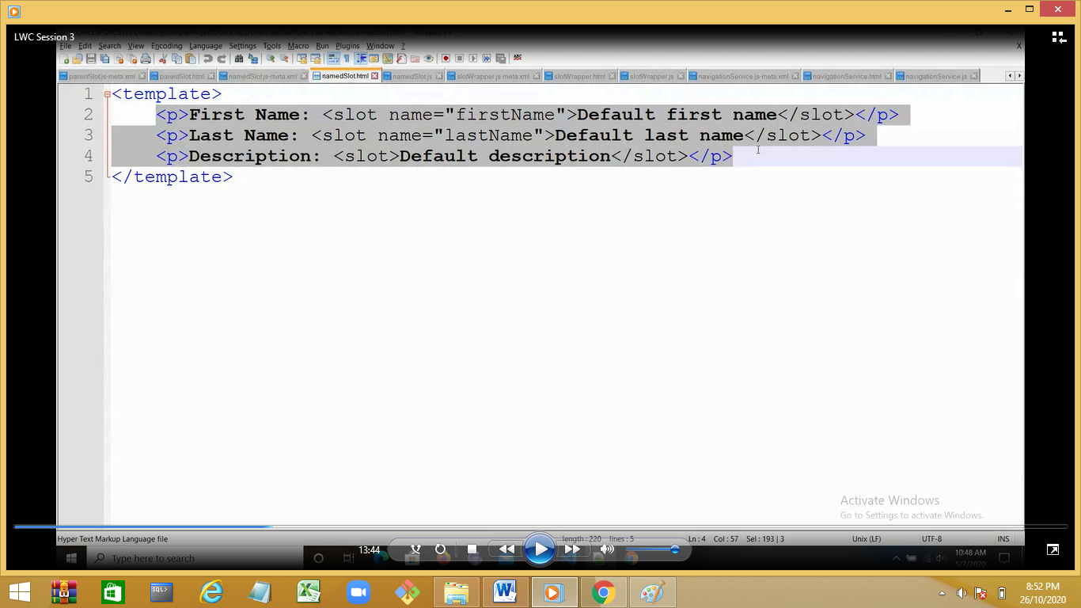

2 slots with name and 1 unnamed slot

Creat 1 more LWC myWrapperSlot

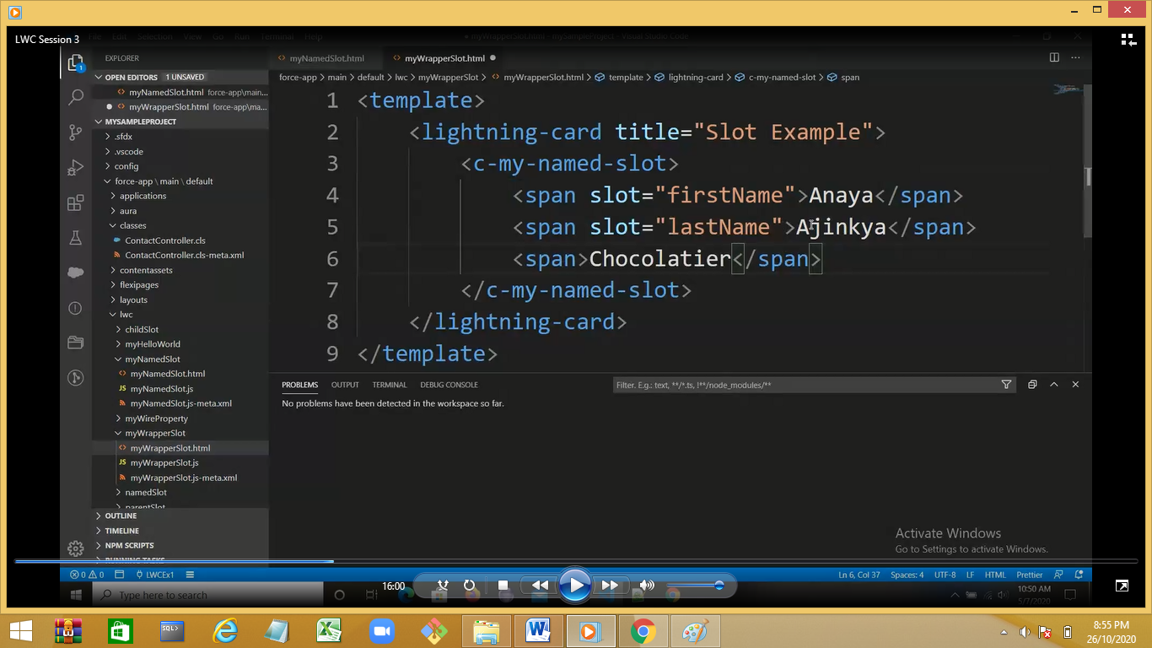

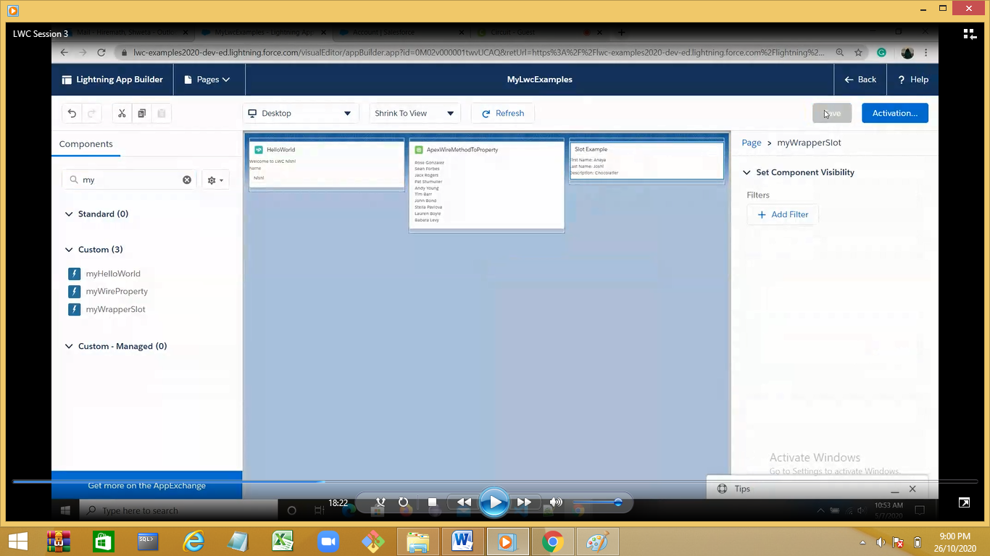

We can have only 1 unnamed slot in 1 template

Demo : comment the unnamed container and check

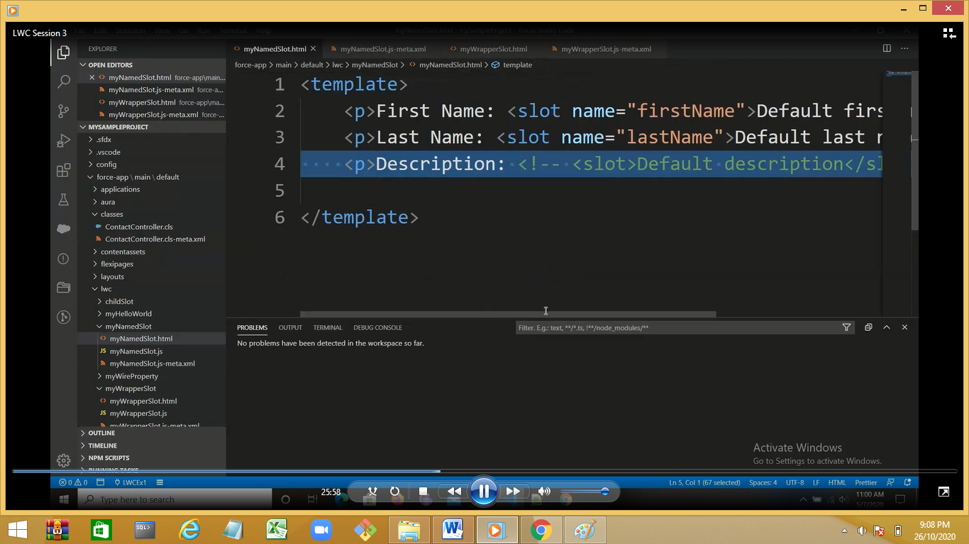

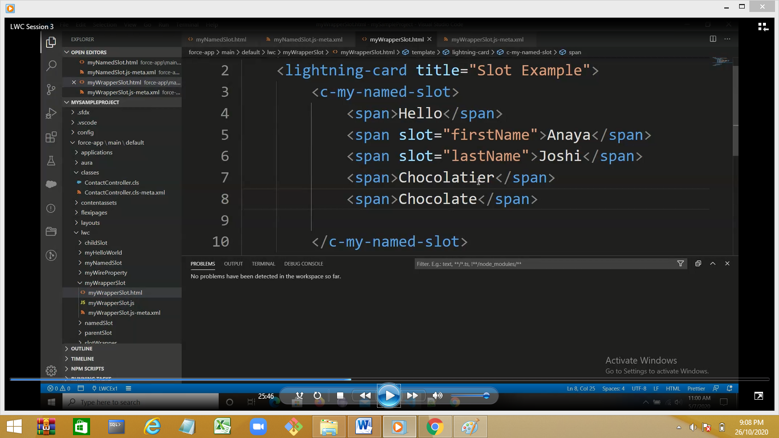

Demo:Slot example.

Create a WLC

myChildSlot

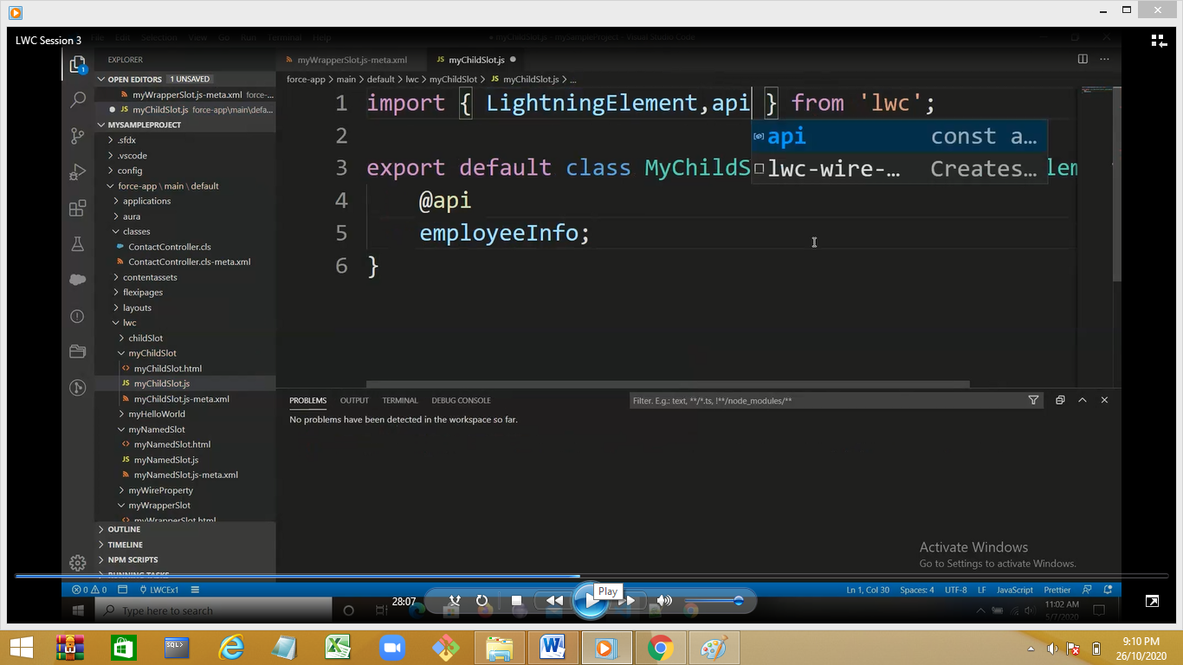

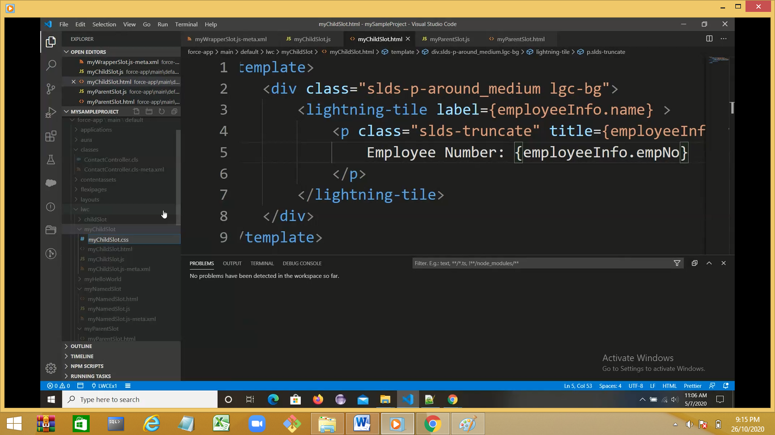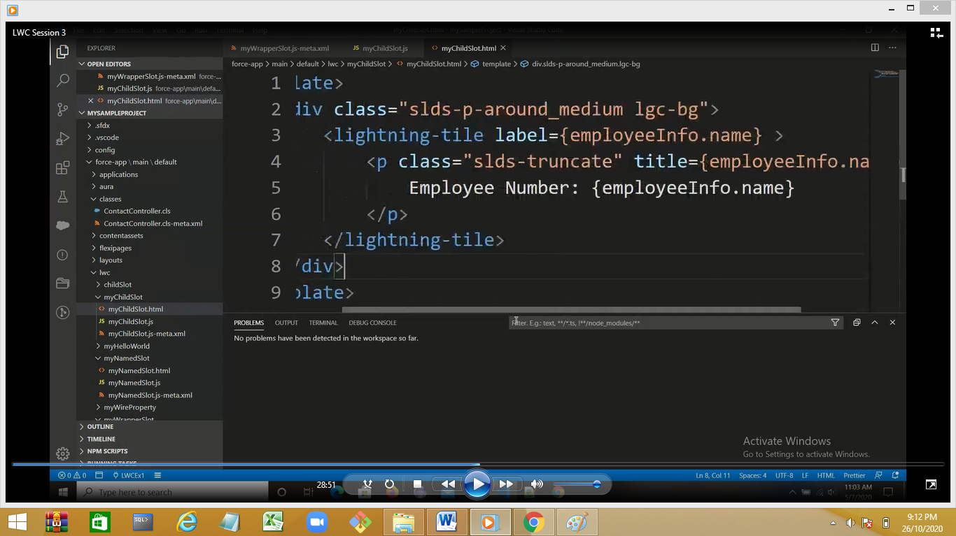

Create a myParentInfo

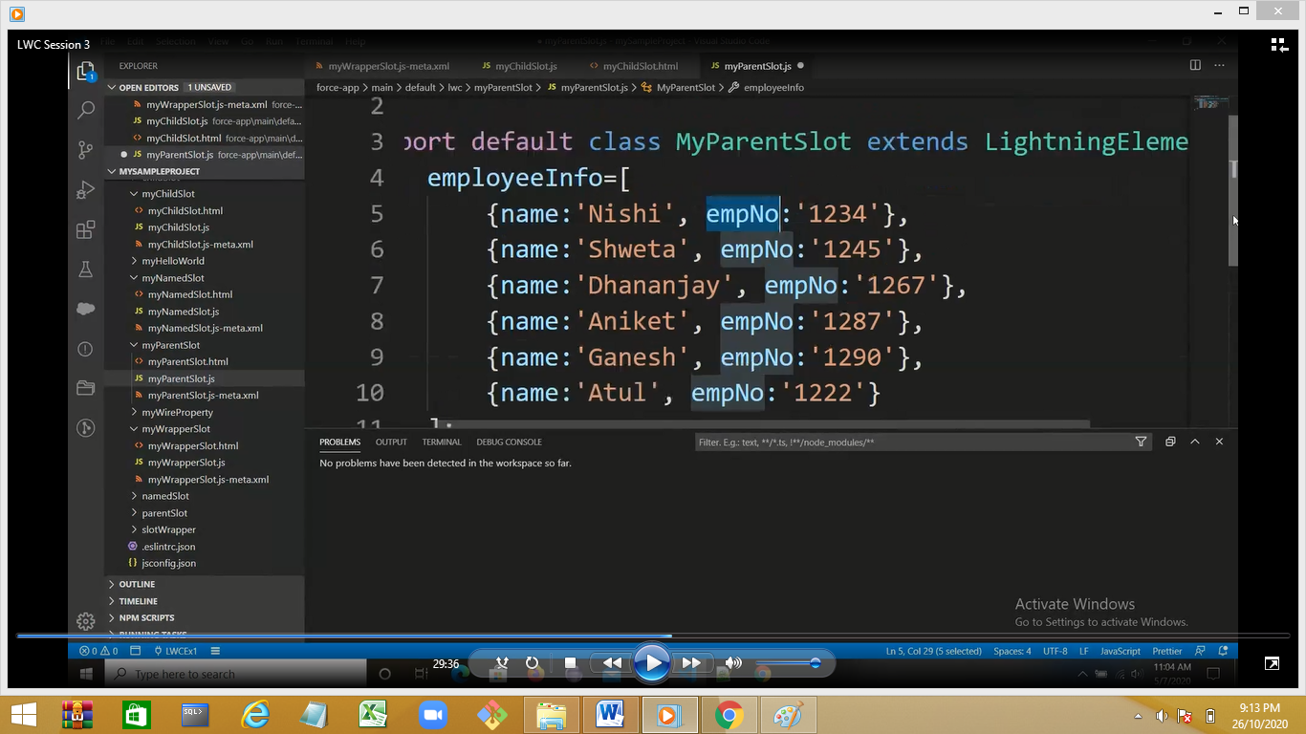

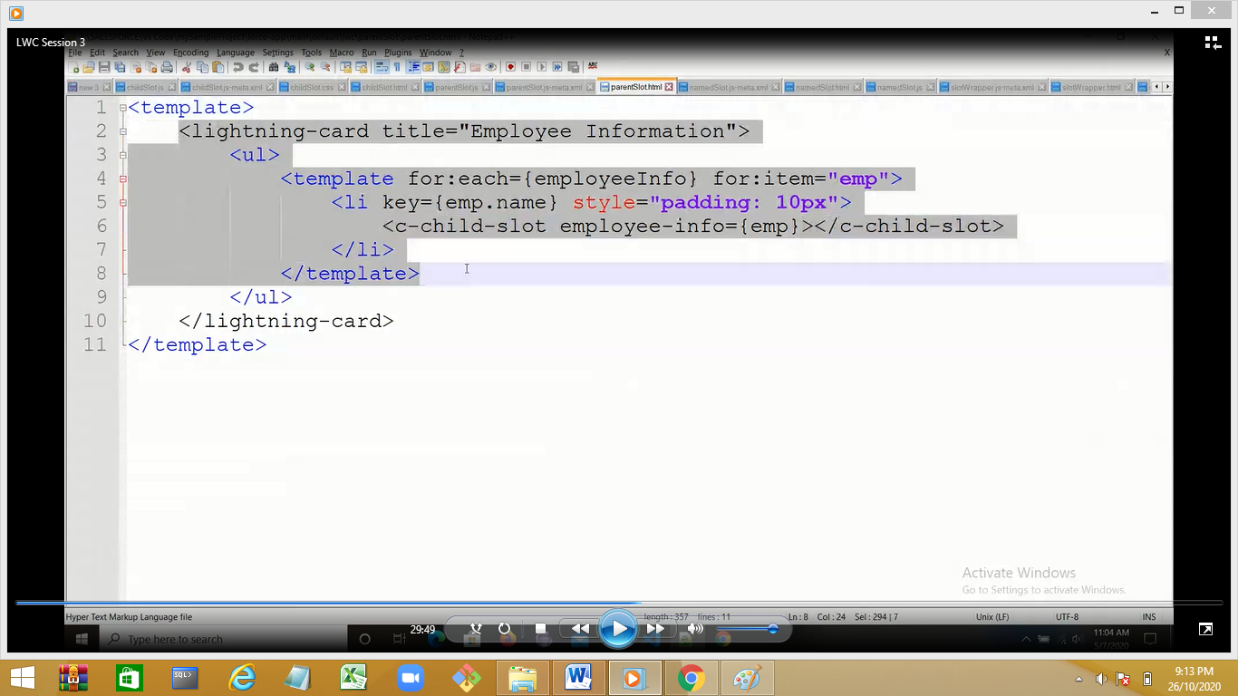

Add css file in child

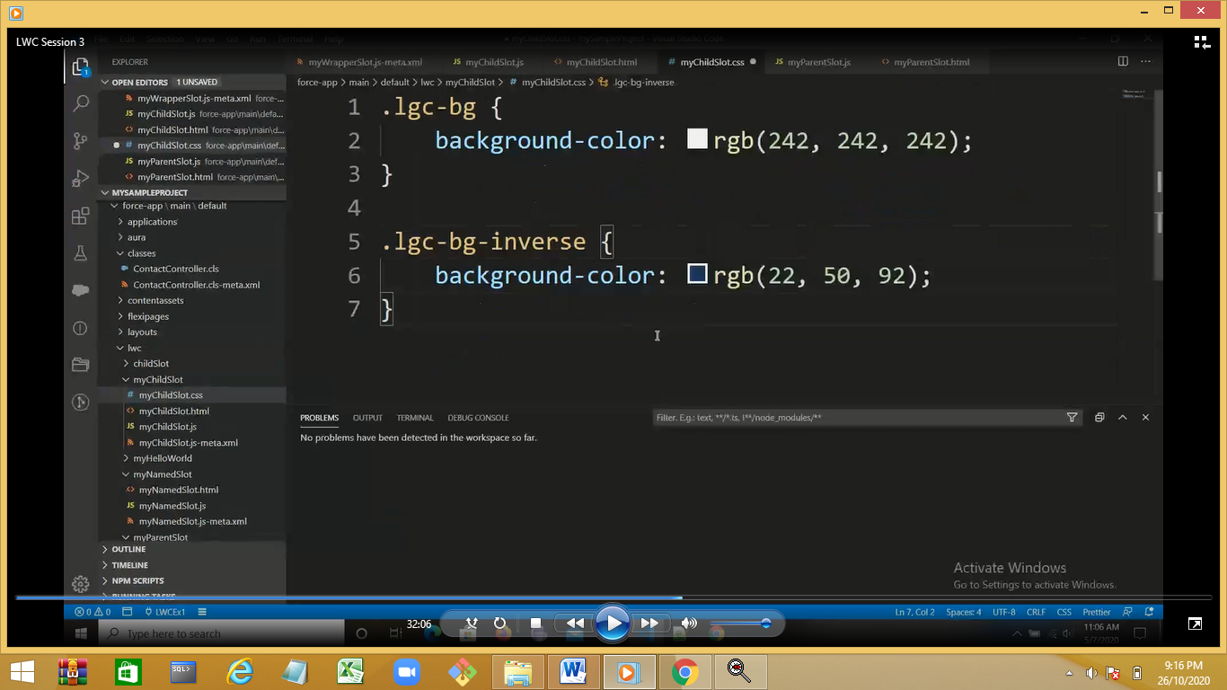

Deploy the component and output

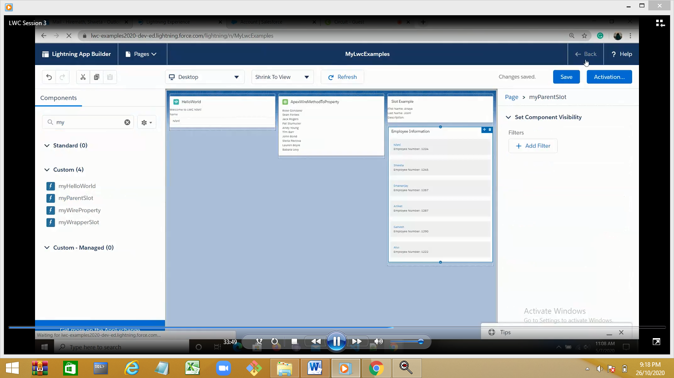

Demo :picklist account object

Create a new component myFetchPicklListValues

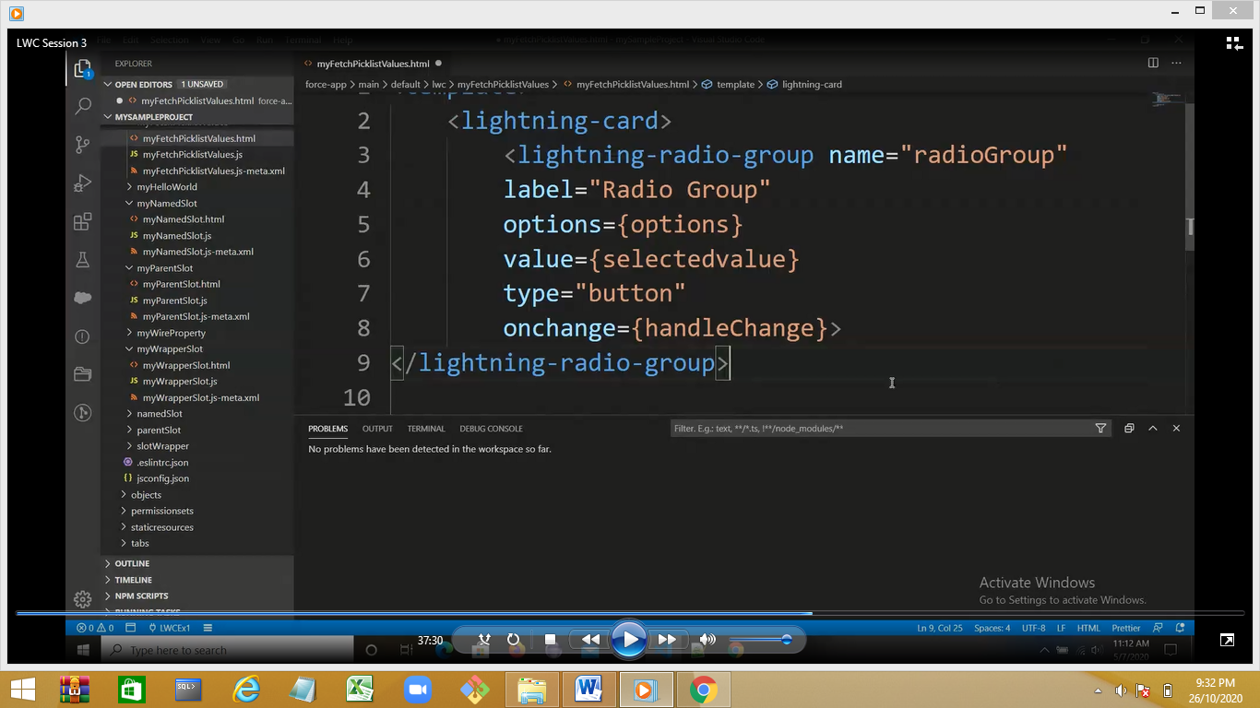

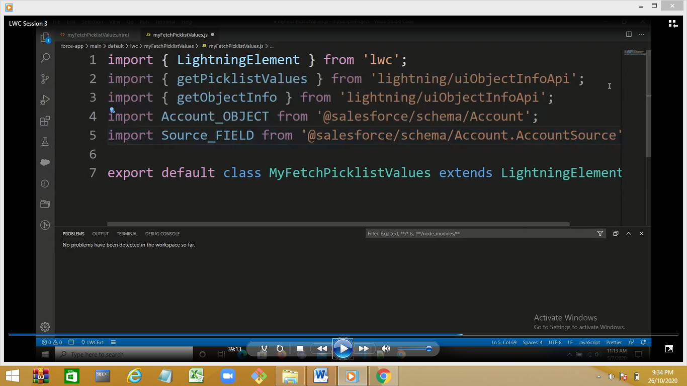

Type is button 